Docker in Action by

Jeff Nickoloff (Manning, 2016).

Oracle Database client:

Install Docker -> Linux 9

Linux 9, 10 & 11

-> PROTOTYPING SOFTWARE - Helps test a newer version of a software say apache 2.4.51 without disturbing the current version being used.

-> ENABLING FULL-STACK PRODUCTIVITY WHEN OFFLINE - Need no connection to staging environment [VPN or office network] to make changes.

-> MODELING NETWORKS - you don't need 6 VMs to check load balancing or failover or load test.

-> REDUCING DEBUGGING OVERHEAD - you are never unaware of changes performed by OS team impacting your application as Docker is in your control.

discuss issues like apache module library LD_LIBRARY_PATH_64, rule for limit on the number of ssh connections per minute.

-> DOCUMENTING SOFTWARE DEPENDENCIES AND TOUCHPOINTS - the DockerFile itself serves as a Documentation data of what the pre-requisites are.

Give example of new setup for digiklug -> node / npm, git, telnet, firewalld, increase swap, authorized_keys which was not in our control and got deleted.

Enable virtualization in bios and Windows OS:

Windows key + X -> App and features -> Programs and features -> Turn Windows feature on or off

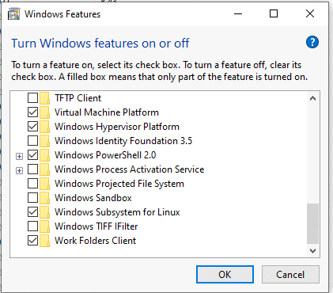

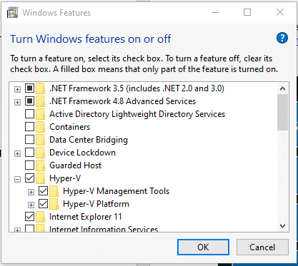

<https://apple.stackexchange.com/questions/224870/how-to-check-vt-x-status-on-macbook-pro>

dive tool for oracle cloud to inspect the size / reduce the size of docker images. -> <https://github.com/wagoodman/dive>

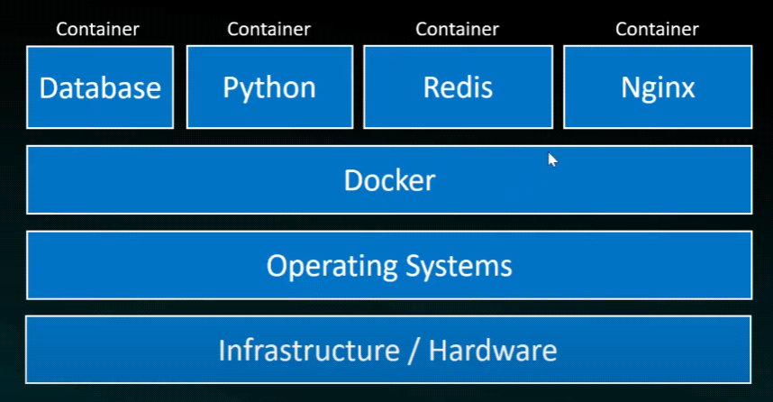

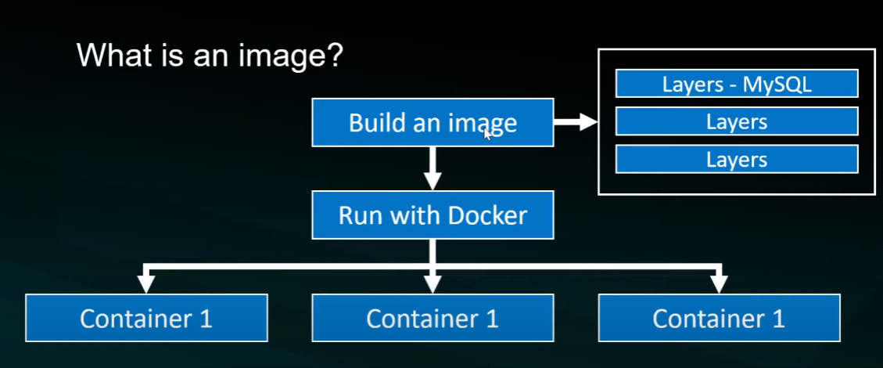

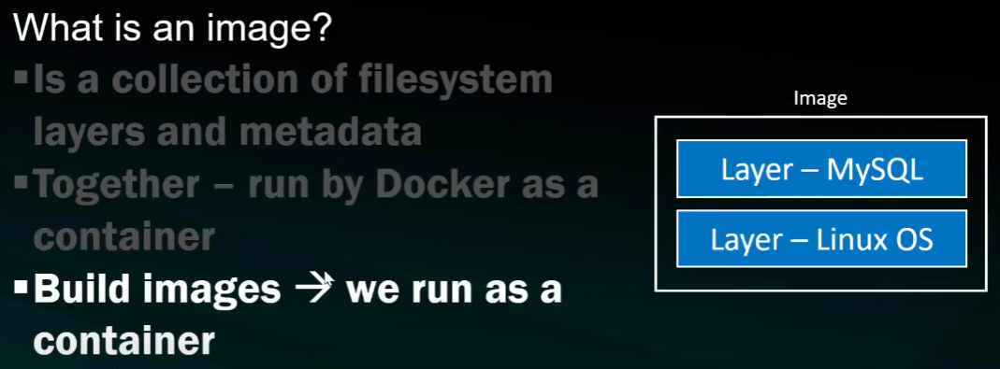

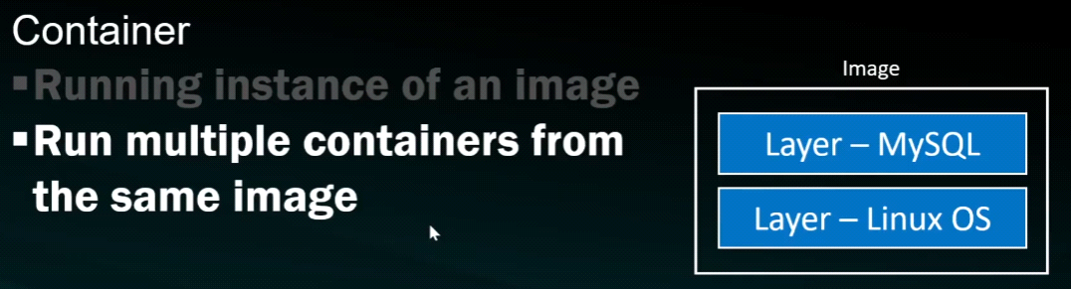

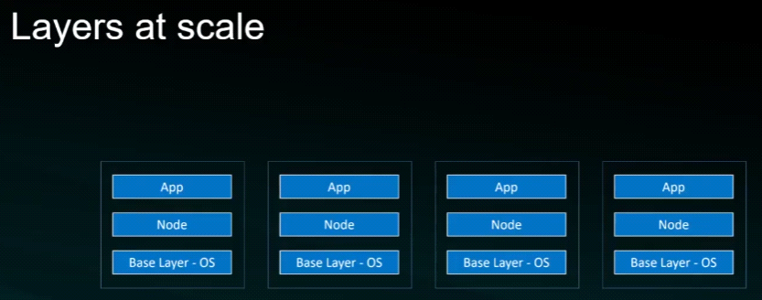

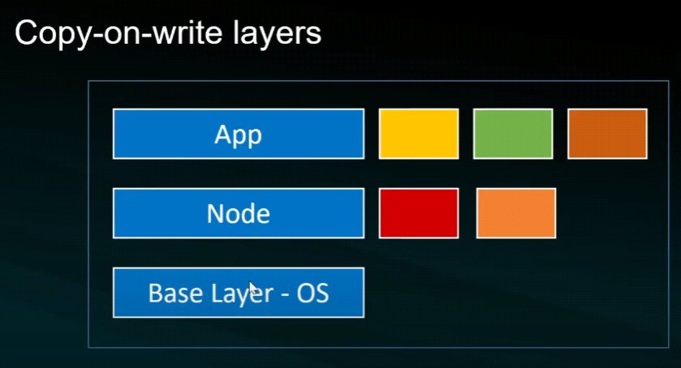

<https://docs.docker.com/desktop/windows/install/>

<https://docs.docker.com/desktop/mac/install/>

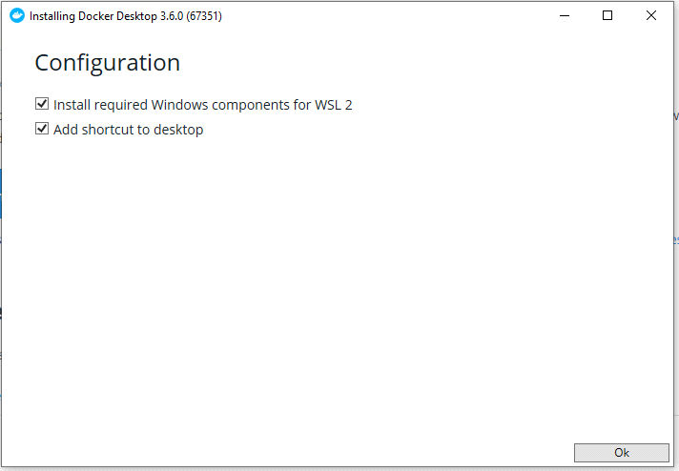

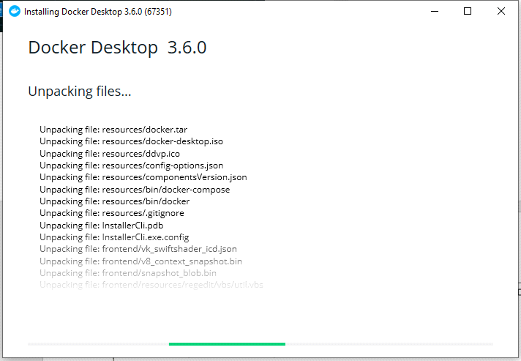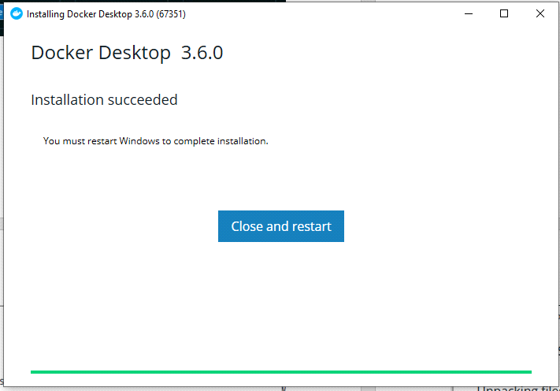

<https://stackoverflow.com/questions/63845591/docker-wsl-2-installation-is-incomplete>

<https://stackoverflow.com/questions/67140019/docker-wsl-2-is-not-installed>

[https://docs.microsoft.com/en-us/windows/wsl/install-win10#step-4---download-the-linux-kernel-update-package](https://docs.microsoft.com/en-us/windows/wsl/install-win10)

G:\>cd Docker_pracs\Chap1-Lab1

G:\Docker_pracs\Chap1-Lab1>docker build .

[+] Building 107.6s (8/8) FINISHED

=> [internal] load build definition from Dockerfile 0.0s

=> => transferring dockerfile: 228B 0.0s

=> [internal] load .dockerignore 0.0s

=> => transferring context: 2B 0.0s

=> [internal] load metadata for docker.io/library/node:latest 3.1s

=> [1/4] FROM docker.io/library/node@sha256:d75b1663c035a5e9ed48ad54041aff3067d6a66104d32d07901314e573393d2a 63.2s

=> => resolve docker.io/library/node@sha256:d75b1663c035a5e9ed48ad54041aff3067d6a66104d32d07901314e573393d2a 0.0s

=> => sha256:d75b1663c035a5e9ed48ad54041aff3067d6a66104d32d07901314e573393d2a 1.21kB / 1.21kB 0.0s

=> => sha256:1cfaf5c6f756207bc4607d40ddd440bd2bfa7ab455b2c3015ccf56d85cd1377b 50.44MB / 50.44MB 34.6s

=> => sha256:e9543f048f0e10a9809a5043dac9bd0aa89f33d2bf816274a58e3cecae1c0459 2.21kB / 2.21kB 0.0s

=> => sha256:c66552d59c4bb478baea52cbcb218071bd7e4741d22ffa9ab541e805f03cdb1d 7.60kB / 7.60kB 0.0s

=> => sha256:c4099a935a96edef1e9378de34e314d07fb3aea1b7205774055a1fa44a3819f4 7.83MB / 7.83MB 2.8s

=> => sha256:f6e2960d83651b1494b4da6c97686e79cc760aa90a75948eed56786726f86928 10.00MB / 10.00MB 3.2s

=> => sha256:dffd4e6385927b79e4d4daa2d00523e766502eed6dd1934e1eda583d348abd8b 51.84MB / 51.84MB 35.7s

=> => sha256:2ce46ad6f244a871abfead80f28a613b68fba68e165467d817e09453b369252f 192.39MB / 192.39MB 51.8s

=> => sha256:5fda1f69c9963463578d3fbcf585bcd8880476b6fa4dd1baf9fea7c07ce4c227 4.20kB / 4.20kB 35.6s

=> => extracting sha256:1cfaf5c6f756207bc4607d40ddd440bd2bfa7ab455b2c3015ccf56d85cd1377b 2.9s

=> => sha256:b084d682aa98d8f00eb1f0fba8e47aaf2c2523c687a6511acd1618bae22b96fc 33.97MB / 33.97MB 46.6s

=> => sha256:3ee73259434e8f3466bbf40d2d48697804b13eaace25fb85d68dfad45fb6f60d 2.26MB / 2.26MB 37.2s

=> => sha256:a2aaca92485c8eca49cf9c0db8e4af7135d18aa800f0dad1200161249c209aaa 285B / 285B 37.4s

=> => extracting sha256:c4099a935a96edef1e9378de34e314d07fb3aea1b7205774055a1fa44a3819f4 0.4s

=> => extracting sha256:f6e2960d83651b1494b4da6c97686e79cc760aa90a75948eed56786726f86928 0.4s

=> => extracting sha256:dffd4e6385927b79e4d4daa2d00523e766502eed6dd1934e1eda583d348abd8b 3.3s

=> => extracting sha256:2ce46ad6f244a871abfead80f28a613b68fba68e165467d817e09453b369252f 9.0s

=> => extracting sha256:5fda1f69c9963463578d3fbcf585bcd8880476b6fa4dd1baf9fea7c07ce4c227 0.0s

=> => extracting sha256:b084d682aa98d8f00eb1f0fba8e47aaf2c2523c687a6511acd1618bae22b96fc 1.8s

=> => extracting sha256:3ee73259434e8f3466bbf40d2d48697804b13eaace25fb85d68dfad45fb6f60d 0.1s

=> => extracting sha256:a2aaca92485c8eca49cf9c0db8e4af7135d18aa800f0dad1200161249c209aaa 0.0s

=> [2/4] RUN git clone -q <https://github.com/docker-in-practice/todo.git> 1.9s

=> [3/4] WORKDIR todo 0.0s

=> [4/4] RUN npm install > /dev/null 38.4s

=> exporting to image 1.0s

=> => exporting layers 1.0s

=> => writing image sha256:79fa51e9ccbb4ee458e8c1276dc67e341da5dec666f43ac6745e8d513d3f2e45 0.0s

Use 'docker scan' to run Snyk tests against images to find vulnerabilities and learn how to fix them

G:\Docker_pracs\Chap1-Lab1>docker images

REPOSITORY TAG IMAGE ID CREATED SIZE

<none> <none> 79fa51e9ccbb 2 minutes ago 956MB

If you wish to use a custom name for your docker file use the -f option like below

G:\Docker_pracs\Chap1-Lab1>docker build -f MyFirstDPrac -t myfirstcont .

Inorder to debug docker build issue and see the nested error run

DOCKER_BUILDKIT=0 docker build -f MyFirstDPrac -t myfirstcont .

How can we see or download node image explicitly?

DOCKER_BUILDKIT=0 docker build -f MyFirstDPrac -t myfirstcont .

From node will get the image online. How to get the image offline?

################################################################

docker run -i -t -p 8000:8000 --name example1 todoapp

To access the application on multiple local ports use the below command

docker run -i -t -p 7878:8000 -p 7979:8000 --name example1 todoapp

G:\Docker_pracs\Chap1-Lab1>docker ps -a

CONTAINER ID IMAGE COMMAND CREATED STATUS PORTS NAMES

b74e0eafc4ce todoapp "docker-entrypoint.s…" 4 minutes ago Exited (1) 30 seconds ago example1

docker run -d -i -p 8000:8000 --name example1 todoapp nc -l 8000

To start a non running container give a different name `example2`:

G:\>docker run -d -it -p 8000:8000 --name example2 todoapp

ab5acaf0fc44f4cbf9e335f02efcd9b7235efceba8e6dcf906858839d3531dc4

G:\>docker ps -a

CONTAINER ID IMAGE COMMAND CREATED STATUS PORTS NAMES

ab5acaf0fc44 todoapp "docker-entrypoint.s…" 19 seconds ago Up 17 seconds 0.0.0.0:8000->8000/tcp, :::8000->8000/tcp example2

b74e0eafc4ce todoapp "docker-entrypoint.s…" 5 hours ago Exited (1) 4 hours ago example1

============================= OR =================================

docker stop b74e0eafc4ce && docker rm b74e0eafc4ce

or simply `docker rm -f b74e0eafc4ce` to stop and remove the running container.

docker run -d -it -p 8000:8000 --name example1 todoapp

docker run -d --restart=always ubuntu echo done

restarts upon failure

dockerd -g /home/dockeruser/mydocker

Point file system used by docker deamon to a custom drive.

Docker on linux does not have dashboard by default. You can access to docker using Docker CLI - docker command. And then if you want to use dashboard, you can install some dashboad that work with docker like Portainer.

Allocate max RAM and SWAP to docker container

sudo docker run -it --memory="1g" ubuntu

Limiting the memory usage of a container with **--memory** is essentially setting a hard limit that cannot be surpassed. Alternatively, you can set a soft limit (**--memory-reservation**) which warns when the container reaches the end of its assigned memory but doesn’t stop any of its services.

sudo docker run -it --memory="1g" --memory-reservation="750m" ubuntu

Limit Docker Container CPU Usage

if you have a host with 2 CPUs and want to give a container access to one of them, use the option **--cpus="1.0"**. The command for running an Ubuntu container with access to 1 CPU would be:

sudo docker run -it --cpus="1.0" ubuntu

You can also use the **--cpu-shares** option to give the container a greater or lesser proportion of CPU cycles. By default, this is set to **1024**.

To run a container with lesser CPU shares, run:

sudo docker run -it --cpu-shares="700" ubuntu

Below example show success and failure depending on what memory we set:

docker run --memory 100m --memory-swap 200m --rm -it progrium/stress --vm 1 --vm-bytes 62914560 --timeout 1ss

Limit the storage for docker container

Update August 2016: as shown below, and in [issue 3804 comment](https://github.com/docker/docker/issues/3804), [PR 24771](https://github.com/docker/docker/pull/24771) and [PR 24807](https://github.com/docker/docker/pull/24807) have been merged since then. [docker run](https://github.com/docker/docker/blob/master/docs/reference/commandline/run.md) now allow to set storage driver options per container

$ docker run -it --storage-opt size=120G ubuntu /bin/bash

* Hacking into the docker container still safeguards the underlying OS barring the file system that is shared.
* The authenticity of a docker container is by matching the Hash SHA of the image of the official webpage and the one which is on your local system.

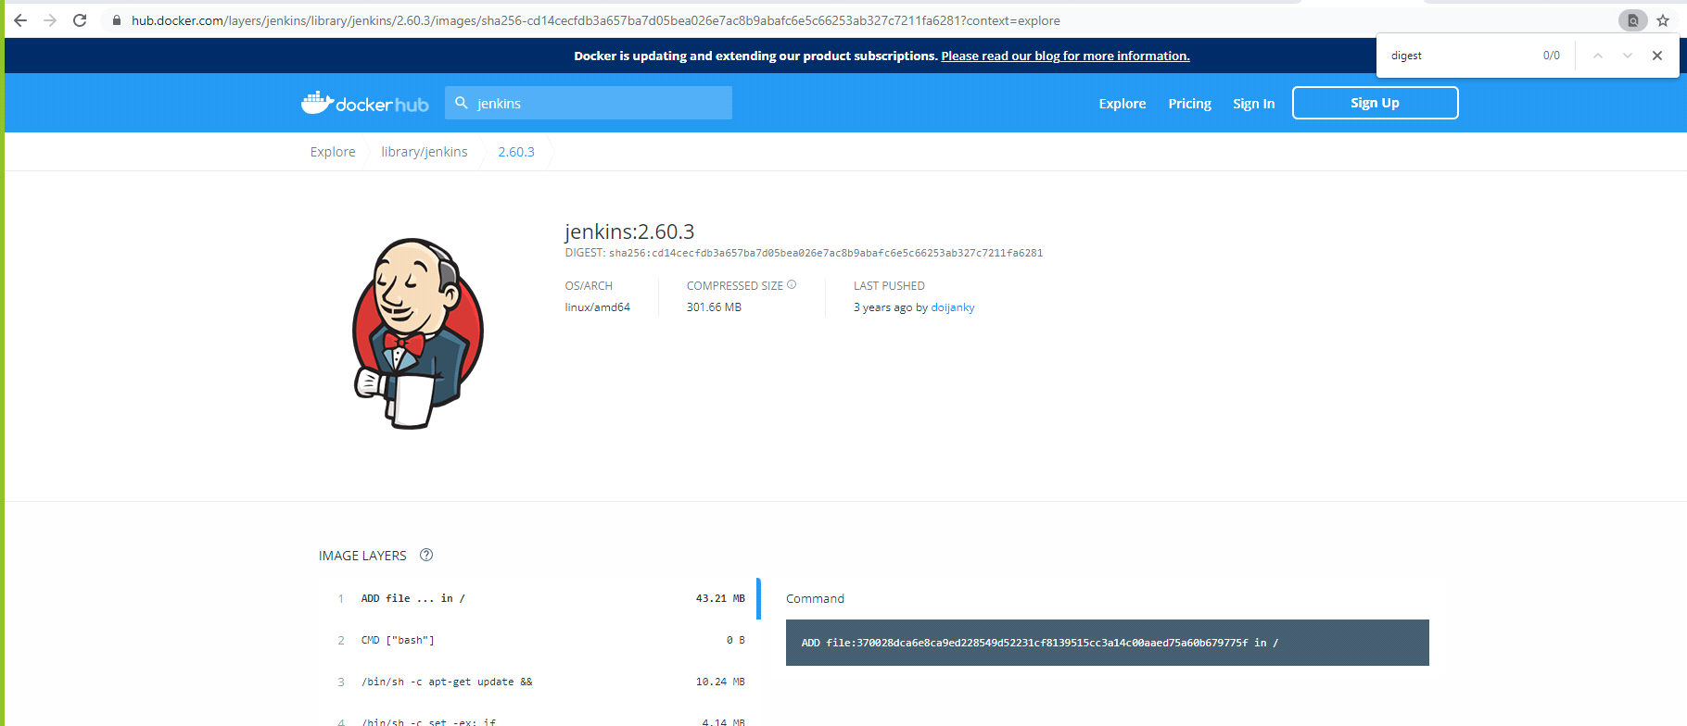

G:\Docker_pracs\Chap1-Lab1>docker images jenkins --digests

REPOSITORY TAG DIGEST IMAGE ID CREATED SIZE

jenkins 2.60.3 sha256:eeb4850eb65f2d92500e421b430ed1ec58a7ac909e91f518926e02473904f668 cd14cecfdb3a 3 years ago 696MB

Digest is <none> for images created locally as the manifest file is missing. Upload your image to repository and the manifest file and digest will be autogenerated.

Below shows where all images are stored as a virtual drive on WSL on Windows.

This as be moved migrated to a new drive or to a new system with a help of a few wsl command-line.

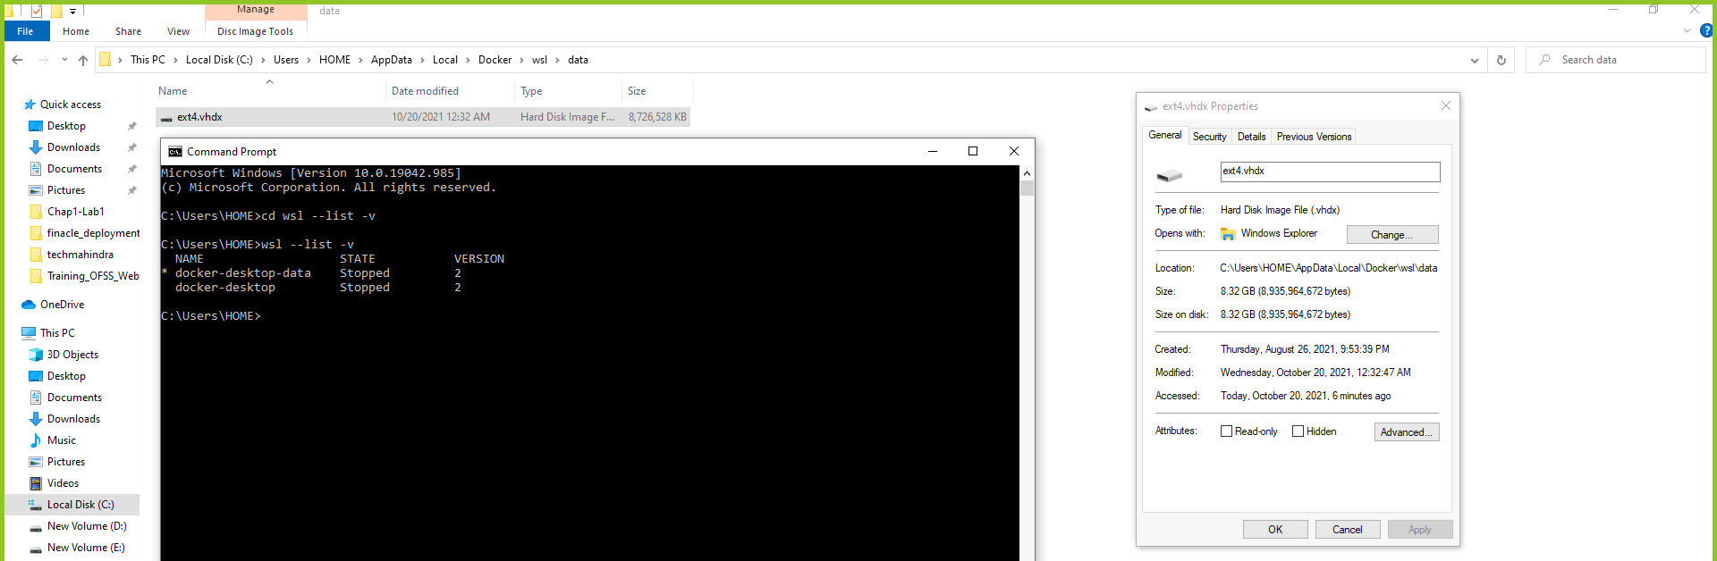

To migrate from one server to another I replaced my WSL2 images with Harsh’s and then the docker images now shows his images instead of mine.

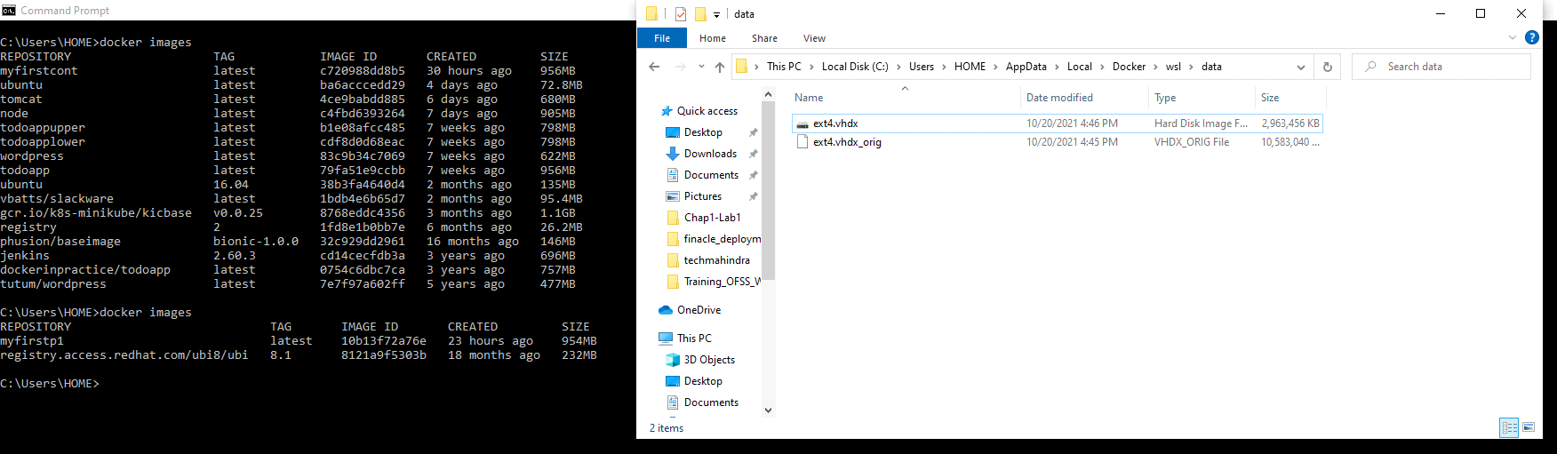

<https://stackoverflow.com/questions/62441307/how-can-i-change-the-location-of-docker-images-when-using-docker-desktop-on-wsl2>

Install git

<https://git-scm.com/download/win>

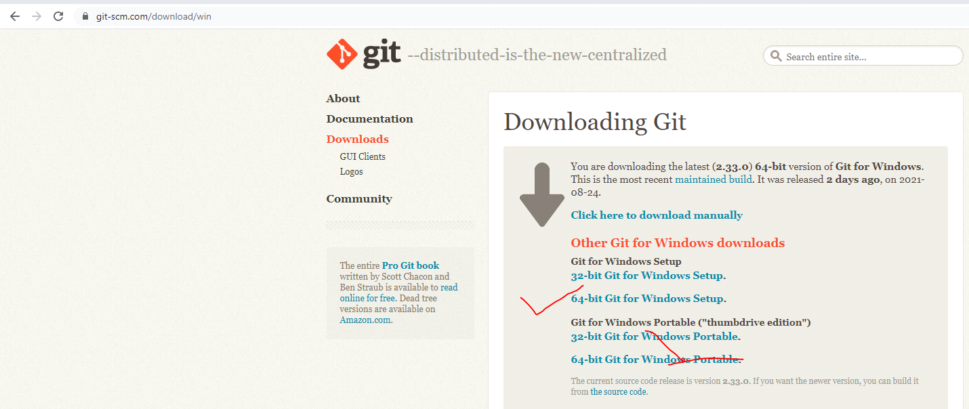

Keep saying next will you reach this where you select this option.

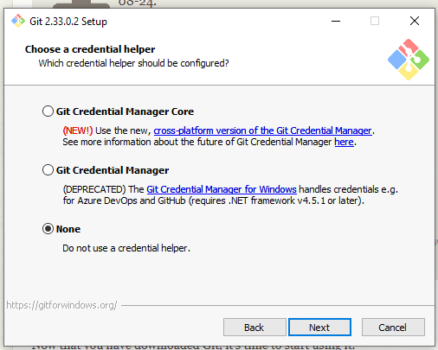

Install python

<https://www.python.org/downloads/release/python-396/>

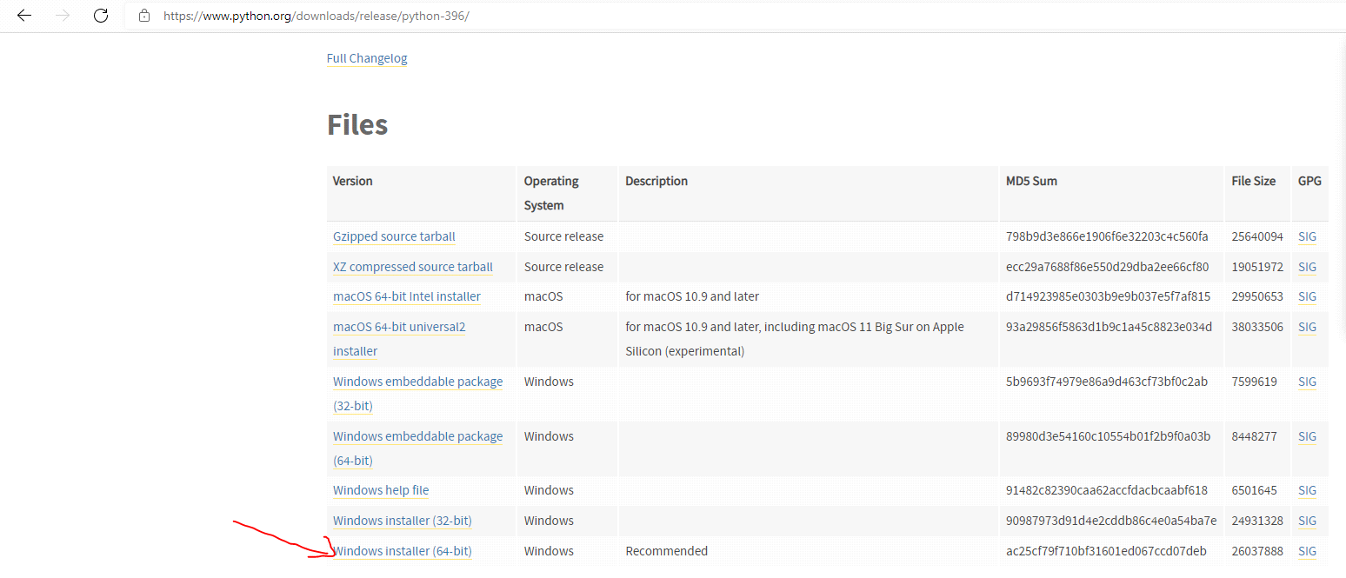

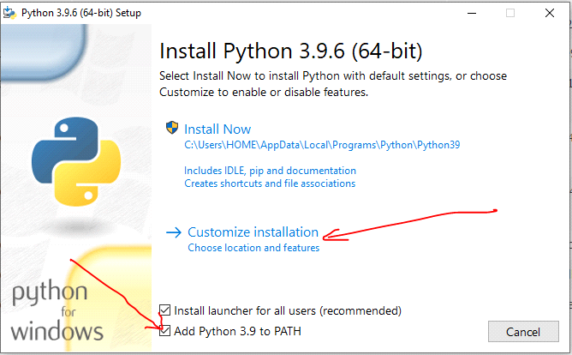 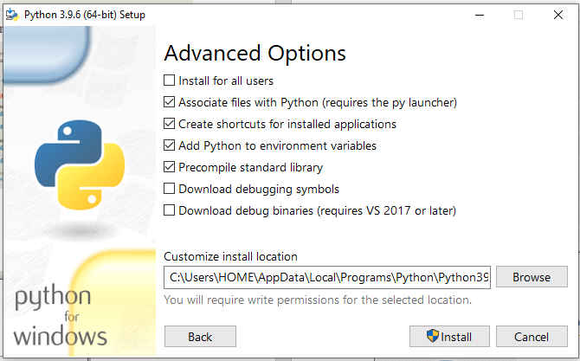

If you’re interested in trying out a new software application, or looking for a new one that serves a particular purpose, Docker images can be an easy way to experiment without interfering with your host machine, provisioning a VM, or having to worry about installation steps.

docker search <product-name>

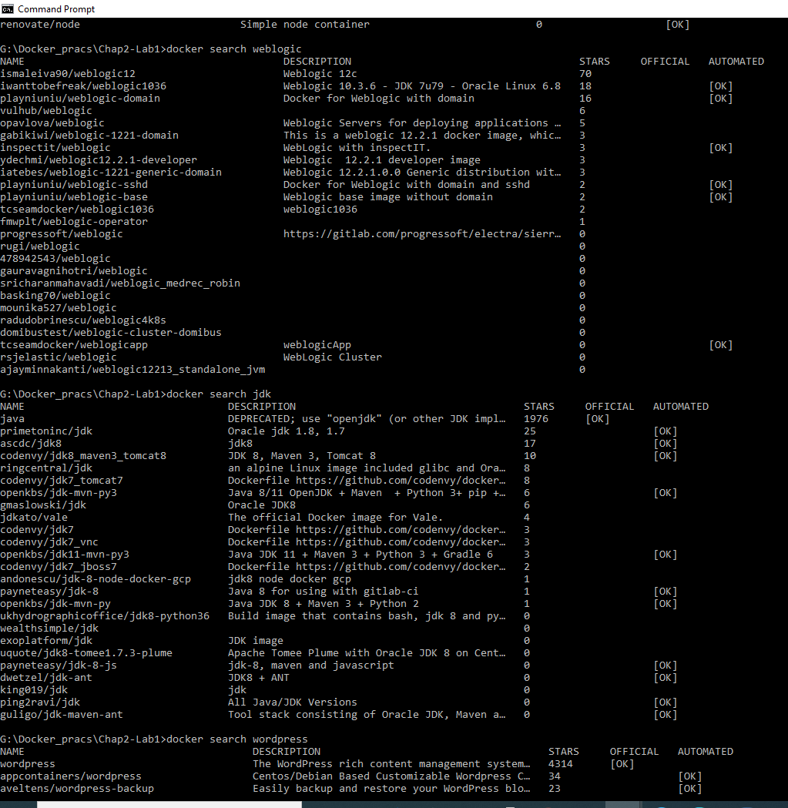

docker pull node

docker run -t -i node /bin/bash

root@c267ae999646:/# node

> process.version

'v7.6.0’

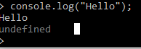

Delete an image -> docker image rm node

HTTP request Response

We http-request contents from server and server sends us response

(http-request)

We(client) -------------------------------------------------------- Server

We(client) -------------------------------------------------------- Server

(http-response)

But this will not work for chatting app where the server cannot send us our friends chat messages to us via i.e (http-response) promptly; unless & until we http-request them for updates.

Solution to this is short-polling where We keep checking for new data (our friends chat messages on the server) at short intervals of time. So we have http-request and response at short periodic intervals.

An improvement to short-polling is long-polling where we request(http-request) for new data and the response(http-response) is held at the server not send back to us unless there is a change in data on the server i.e., until our friends new chat response text is received at the server.

The webSocket protocol does not work on request and response model.

After the initial hand-shake the server is capable for sending and receiving messages with everyone it is connected to.

So; if the server is connected to 20 people that we chat, once we send hi message to the server the server can send our message to all the 20 recipients who are connected to the server without them having the need to send either a short or long poll http request. This is more real time than the other approach which may have delay.

Most web browsers use web sockets.

* Web socket is a protocol whereas socket.io is a java script library.

Socket.io detect and changes the connection between a server and client to websockets when it is possible else it will switch to http polling method.

Switching from one protocol to another is taken care by socket.io and we do not have to worry about it.

Docker terminal uses WebSockets, which don’t currently work through proxies

You want to make multiple Docker container services available on a port from your host machine

Use Docker’s -p flag to map a container’s port to your host machine.

To obtain images from external locations, you can use the docker pull command. By default, images will be downloaded from the Docker Hub:

$ docker pull tutum/wordpress

If image is not present and you docker run it will be automatically pulled.

docker run -d -p 10001:80 --name blog1 tutum/wordpress

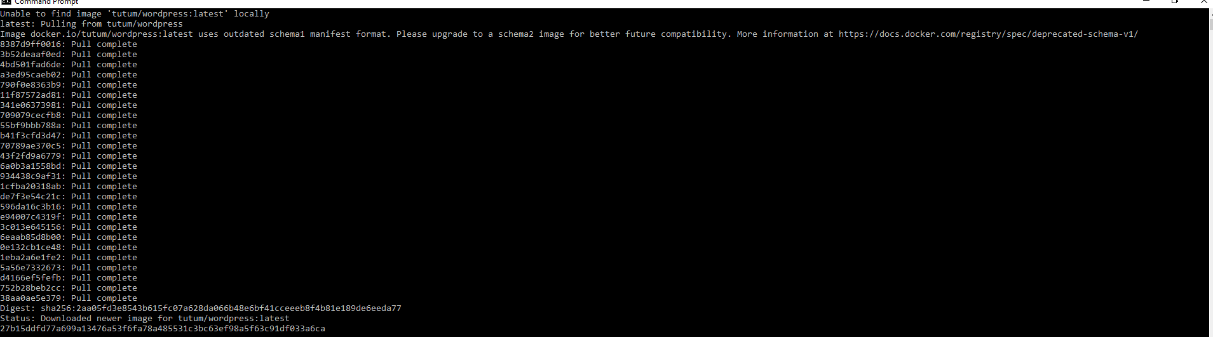

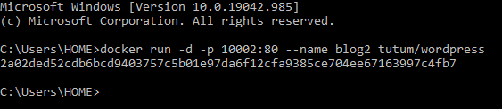



To remove the containers when you’re finished (assuming you don’t want to keep them—we’ll make use of them in the next technique), run this command:

$ docker rm -f blog1 blog2

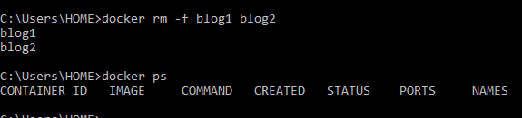

Problem:

You want to allow communication between containers for internal purposes.

Solution:

Employ user-defined networks to enable containers to communicate with each other.

First you’ll need to create a user-defined network:

$ docker network create my_network

Next,

C:\Users\HOME>docker network connect my_network blog1

Error response from daemon: No such container: blog1



Give containing names if the requests comes in to the container. If it is only outgoing requests you don’t need to give container names.

Giving containers names is very useful for assigning memorable hostnames you can later refer to, but it’s not strictly necessary—if connections are only outgoing, then you probably won’t need to look up the container. The same is obvious from the example below.

How-to Start containers along with assigning network name and using it to test both containers blog1 and blog2 networks.

docker run -it --network my_network ubuntu:16.04 bash

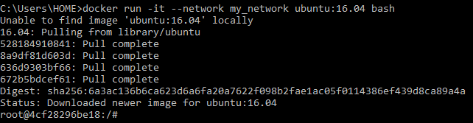

$ apt update && apt install -y curl

curl -sSL blog1 | head -n5

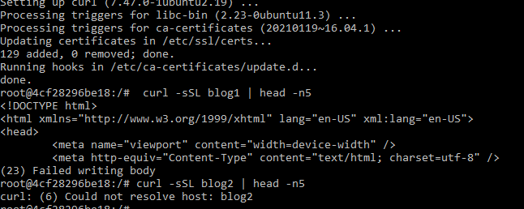

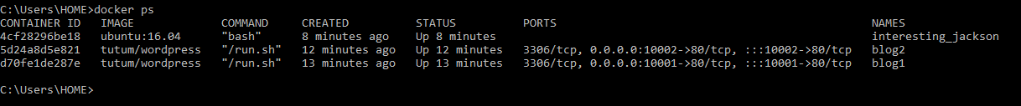

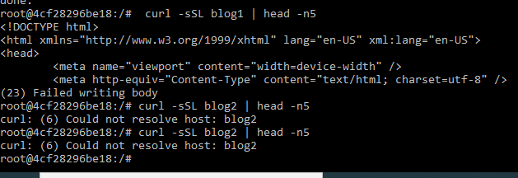

This is what makes the difference:

docker network connect my_network blog1

Adding a container to a new network does not remove it from the previous network.

By default all containers get connect to a default network called the “bridge” network.

docker run --name wp-mysql -e MYSQL_ROOT_PASSWORD=yoursecretpassword -d mysql

Once the backend services are started then run frontend wordpress

docker run --name wordpress --link wp-mysql:mysql -p 10003:80 -d wordpress

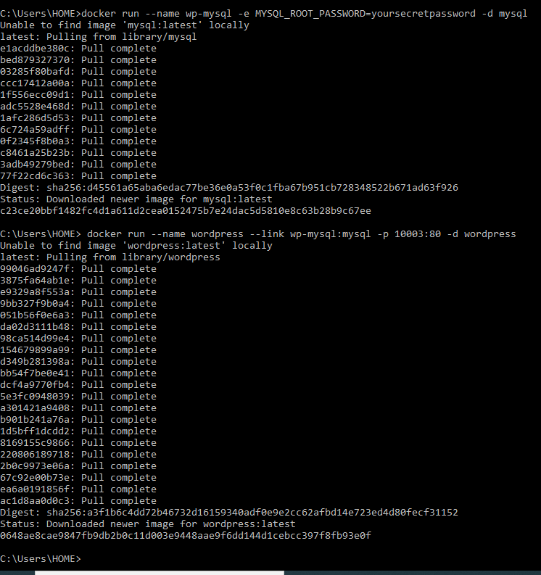

This has the significant benefit that different MySQL containers can be swapped in without requiring any change at all to the WordPress container, making configuration management of these different services much easier.

docker logs wp-mysql 2>&1 | findstr /C:"ready for connections"



Inspect Docker Network or a Docker Image

docker network inspect testnetwork1

C:\Users\HOME>docker image inspect myfirstcont

docker network inspect my_network

docker network ls

docker container ls

docker network connect my_network blog1

docker network inspect my_network

docker network disconnect my_network blog1

docker network inspect my_network

docker network rm my_network

docker network rm -f my_network

docker network disconnect my_network blog2

docker network rm my_network

<https://www.papertrail.com/solution/tips/how-to-live-tail-docker-logs/>

Get exit code of a container

<https://docs.docker.com/engine/reference/commandline/attach/>

The ADD Dockerfile command (unlike its sibling command COPY) unpacks TAR files (as well as gzipped files and other similar file types) when they’re placed in an image like this.

WARNING Creating a TAR from a running system may seem like the easiest option (no shutdowns, installing software, or making requests to other teams), but it has a severe downside—you could copy a file in an inconsistent state and hit strange problems when trying to use your new Docker image. If you must go this route, first stop as many applications and services as possible.

Differences between VMs and Docker containers These are a few of the differences between VMs and Docker containers: Docker is application-oriented, whereas VMs are operating-system oriented. Docker containers share an operating system with other Docker containers. In contrast, VMs each have their own operating system managed by a hypervisor. Docker containers are designed to run one principal process, not manage multiple sets of processes.

docker run -d phusion/baseimage:bionic-1.0.0

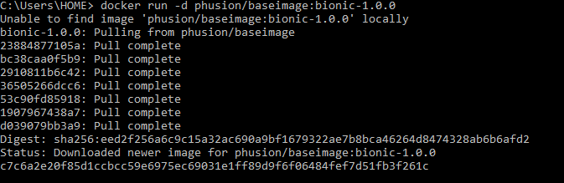

Get the container ID using command -> docker ps

docker exec -it c7c6a2e20f85 /bin/bash

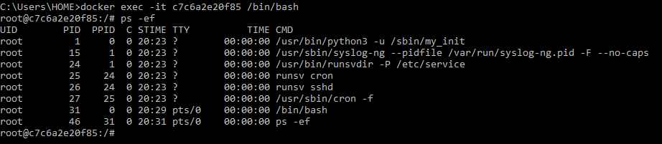

If you still want to run multiple processes from within a container, there are specific tools that can help you do that. One of these—Supervisord— is treated in the next technique.

Listing 3.20 An image with multiple tags

C:\Users\HOME>docker commit todobug1 todobuguppercase

sha256:5d5172647da36e7a539f7e4b7a018d531f6dae61b08ddb12d488eb4dea42af3e

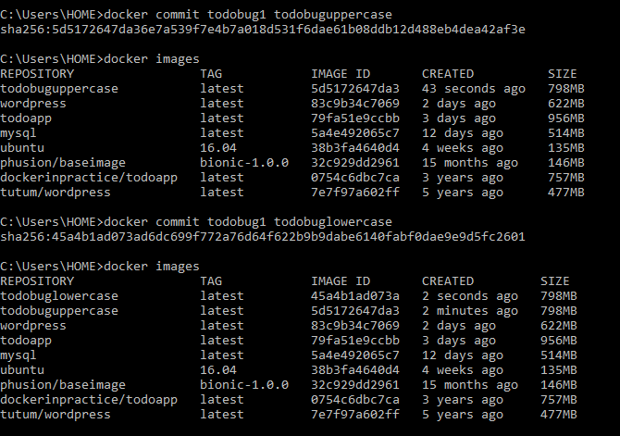

C:\Users\HOME>docker run -d -p 8001:8000 todobuguppercase

1847e6a9d88b465684d1a8e4509d27026fe46230b51347aabbb44d3a7da70d42

C:\Users\HOME>docker run -d -p 8001:8000 todobuglowercase

d029f89880dbaa206a168e31af0fc3cd7647b443e64b63cfe70c8f7b31f197ee

docker: Error response from daemon: driver failed programming external connectivity on endpoint youthful_nobel (ebe4f667fece00138f35acca0dc562a0b01b2b131386b27393dff7131caf4c8c): Bind for 0.0.0.0:8001 failed: port is already allocated.

C:\Users\HOME>docker run -d -p 8002:8000 todobuglowercase

4223b8f382adc8b527104f8e5df8c6140b16d820ea36bb000841926b28108013

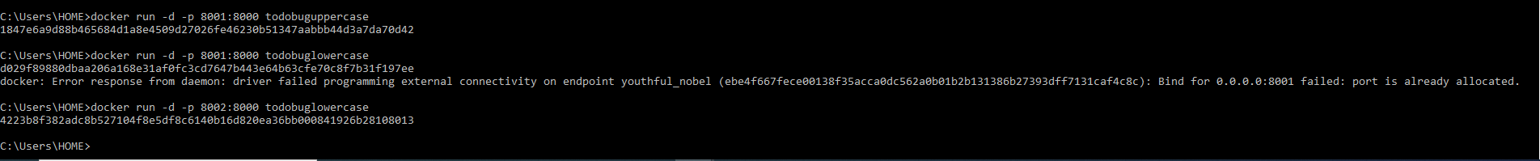

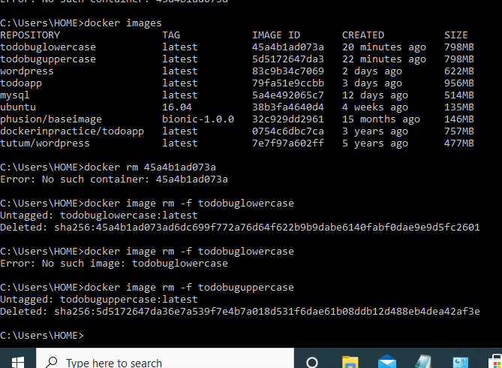

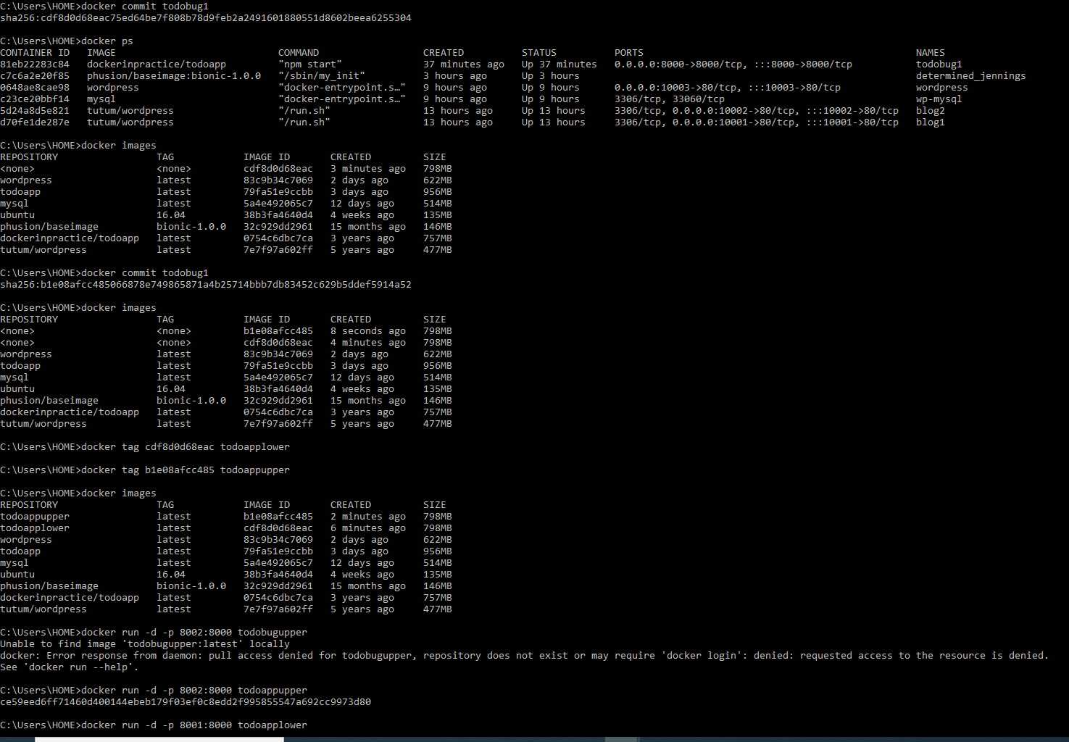



You want to access files on the host from within a container.

docker run -v /var/db/tables:/var/data1 -it debian bash

Volume mapping for a Windows Docker System

docker run --name=nginx -d -p 5000:80 -v %homedrive%%homepath%\nginxlogs:/var/log/nginx -v C:\Users\HOME\Desktop:/root/mydesktopdata nginx

C:\Users\HOME>docker exec -it nginx /bin/bash

C:\Users\HOME>docker container rm -f nginx

Steps for Deploying a Static HTML Site with Docker and Nginx



Step 1 - Create a Directory for the Website

Make sure that you have your HTML files already in the current directory.

Step 2 - Create a file called Dockerfile

Place the following contents into the Dockerfile

FROM nginx:alpine  
COPY . /usr/share/nginx/html

These lines of code represent the image we're going to use along with copying the contents of the current directory into the container.

Step 3 - Build the Docker Image for the HTML Server

Run the following command:

docker build -t html-server-image:v1 .

You can confirm that this has worked by running the command:

docker images

And it should show you output something like this:

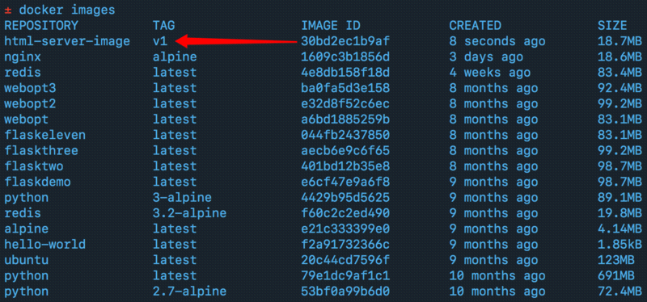

Step 4 - Run the Docker Container

Run the following command to run the HTML container server:

docker run -d -p 80:80 html-server-image:v1

Step 5 - Test the Port with cURL

Run the following command to ensure the server is running:

curl localhost:80

You can also view it in the browser now by going to localhost:80 and you should see your HTML file, as shown below:

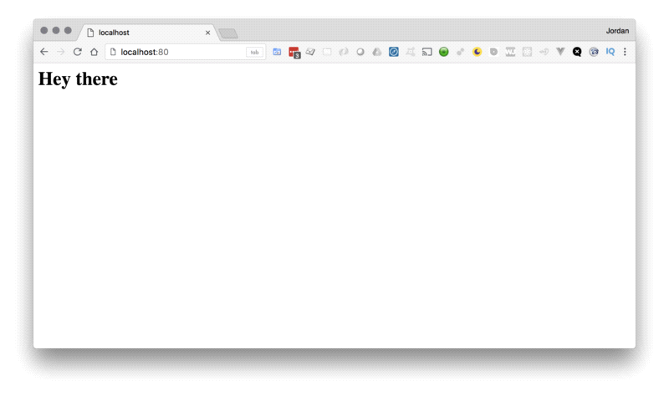

Inorder to push publish image to localhost:

docker run -d -p 5000:5000 -v $HOME/registry:/var/lib/registry registry:2 --insecure-registry localhost

docker run -d -p 5000:5000 --restart=always --name registry registry:2

docker tag postgres localhost:5000/postgres

docker push localhost:5000/postgres

In order to push/publish images to Docker Hub.

Register to docker hub with username “docgans00089” and password “Harsith2110”

C:\Users\HOME\regclient>docker login -u docgans00089 -p Harsith2110

WARNING! Using --password via the CLI is insecure. Use --password-stdin.

Login Succeeded

C:\Users\HOME\regclient>

C:\Users\HOME\regclient>docker tag <repository> <username>/<repository>

C:\Users\HOME\regclient>docker tag newcontainerwithbalajicommit docgans00089/newcontainerwithbalajicommit

C:\Users\HOME\regclient>docker push docgans00089/newcontainerwithbalajicommit

Using default tag: latest

The push refers to repository [docker.io/docgans00089/newcontainerwithbalajicommit]

689528566606: Pushed

b0c360818224: Pushed

d35aa7fd29b6: Pushed

c0eeb6e15fd7: Pushed

91cba8fa7129: Pushed

latest: digest: sha256:0da704907aa32e2b8655c0f81b64d794d20219bb5ae0b39426a9009f18de4f0a size: 1362

C:\Users\HOME\regclient>

On the third system with a different login:

docker pull docgans00089/newcontainerwithbalajicommit

docker run -i -t --name example2 docgans00089/newcontainerwithbalajicommit /bin/bash

cat ~/balagi.txt

C:\Users\HOME\regclient>docker logout

Removing login credentials for <https://index.docker.io/v1/>

Step 1 — Bindmounting a Volume

The following command will create a directory called nginxlogs in your current user’s home directory and bindmount it to /var/log/nginx in the container:

t

Copy

Let’s take a moment to examine this command in detail:

* --name=nginx names the container so we can refer to it more easily.
* -d detaches the process and runs it in the background. Otherwise, we would just be watching an empty Nginx prompt and wouldn’t be able to use this terminal until we killed Nginx.
* -v ~/nginxlogs:/var/log/nginx sets up a bindmount volume that links the /var/log/nginx directory from inside the Nginx container to the ~/nginxlogs directory on the host machine. Docker uses : to split the host’s path from the container path, and the host path always comes first.
* -p 5000:80 sets up a port forward. The Nginx container is listening on port 80 by default. This flag maps the container’s port 80 to port 5000 on the host system.
* nginx specifies that the container should be built from the Nginx image, which issues the command nginx -g "daemon off" to start Nginx.

**Note:** The -v flag is very flexible. It can bindmount or name a volume with just a slight adjustment in syntax. If the first argument begins with a / or ~/, you’re creating a bindmount. Remove that, and you’re naming the volume.

* -v /path:/path/in/container mounts the host directory, /path at the /path/in/container
* -v path:/path/in/container creates a volume named path with no relationship to the host.

For more on named volumes, see [How to Share Data Between Docker Containers](https://www.digitalocean.com/community/tutorials/how-to-share-data-between-docker-containers)

Step 2 — Accessing Data on the Host

We now have a copy of Nginx running inside a Docker container on our machine, and our host machine’s port 5000 maps directly to that copy of Nginx’s port 80.

Load the address in a web browser, using the IP address or hostname of your server and the port number: [http://your_server_ip:5000](http://your_server_ip:5000/). You should see:



More interestingly, if we look in the ~/nginxlogs directory on the host, we’ll see the access.log created by the container’s nginx which will show our request:

* cat ~/nginxlogs/access.log

Copy

This should display something like:

Output

203.0.113.0 - - [11/Jul/2018:00:59:11 +0000] "GET / HTTP/1.1" 200 612 "-"

"Mozilla/5.0 (Windows NT 10.0; WOW64) AppleWebKit/537.36

(KHTML, like Gecko) Chrome/54.0.2840.99 Safari/537.36" "-"

If you make any changes to the ~/nginxlogs folder, you’ll be able to see them from inside the Docker container in real time as well.

Conclusion

In this tutorial we demonstrated how to create a Docker data volume to share information between a container and the host file system. This is helpful in development environments, where it is necessary to have access to logs for debugging. To learn more about sharing persistent data between containers, take a look at [How HYPERLINK "https://www.digitalocean.com/community/tutorials/how-to-share-data-between-docker-containers"To HYPERLINK "https://www.digitalocean.com/community/tutorials/how-to-share-data-between-docker-containers" HYPERLINK "https://www.digitalocean.com/community/tutorials/how-to-share-data-between-docker-containers"Share Data between Docker Containers](https://www.digitalocean.com/community/tutorials/how-to-share-data-between-docker-containers).

In part 1: the [basics of Docker](https://mikehuls.medium.com/docker-for-absolute-beginners-what-is-docker-and-how-to-use-it-examples-3d3b11efd830) we’ve focussed on building a Docker image. Creating a container from that image was pretty easy, executing a single command. Docker-compose automates this further. In this article we are going to create a file that contains the run-configuration for multiple containers. Then, with a single command, we can then build all images and run all containers with a single command!

We’re going to explore compose with the help of a detailed example for a multi-container application. We’re going to spin up multiple, interconnected containers. You can use this walkthrough as a guide for your own projects. At the end of this article you’re able to:

* Understand what Docker Compose is and how it works
* See what advantages Docker Compose adds to Docker to make your life easier
* Understand when to use Docker Compose
* Are able to use Compose to spin up and manage multiple containers
* Are able to brag about automating a lot of your infrastructure

**1. Why use docker compose?**

In this part, we’re going to go through the main reasons to use Compose.

All of your configuration in one file

Compose revolves around a config file called docker-compose.yml. In it we define all of our services. Think of a service as a part of your application; a database or API for example. All of our services rely on an image with which we create a container. Spinning up a container can have many options; how these options are configured will be stored in the yml file.

An example of these run options is the port mapping that we’ve define in [part 1](https://mikehuls.medium.com/docker-for-absolute-beginners-what-is-docker-and-how-to-use-it-examples-3d3b11efd830). We had to call docker run —publish 5000:5000 python-docker in our terminal. Compose allows us to define these options in a file. We’ll see an example of this later.



Compose organizes all of our services in containers (image by [Tom Fisk](https://www.pexels.com/@tomfisk) one Pexels)

Another benefit of having all of our services with all their corresponding build options in one file is that we can build and run all of our services at once calling docker-compose up!

Using environment variables

Running our containers can be made more flexible with environment variables. We can provide the docker-compose up command with a file that contains some environment variables. This way we can securely provide passwords without hardcoding these into the config file.

An example: we’ll create a file called .env that has DBPASSWORD=secretpass. We can then use DBPASSWORD as a variable in the docker-compose.yml.

In order to do so we specify our env file in calling docker-compose: docker-compose --env-file .env up. This keeps our passwords out of our repositories and docker-compose.yml. Also it offers more flexibility and a neater project since our passwords aren’t hardcoded anymore.

Shared container network

When we spin up our containers with Compose, it defines a network that all our services share. This means that all services can communicate internally.

Let’s illustrate this with an example. Imagine we hosted our application on beersnob.com. When our API needs to communicate with our database it doesn’t need to connect via beersnob.com:5432 but can instead just call the database internally. This is great for security because it means that only our services have access to our database, clients cannot reach the service from outside the application.

Portability and version control

Since we have all of our config in one file we can easily share this file via a version control system like Git. Users can just pull the docker-compose.yml and source code and they have all containers running! An extra benefit is that we keep an entire history of all changes that we make to our configuration so that we can restore a previous version whenever we want. This also makes it easier to set up a CI/CD pipeline for this application, which we’ll get into in a future part.

Flexibility

Since all of our services are completely isolated from one another we can easily add a new service. Maybe in the future our app needs some caching → just spin up a Redis container! Other services like our API can the easily connect to the new Redis service over the internal network.

**2. How Docker works: creating our first container**

Okay, enough talking; let’s see some code! In order to really understand how Compose works and how to use it, we’re going to build a containerized application.

2.1. Goals

We’re creating an application called **BeerSnob**; a site that’s specially made for drinkers of fine beers. It allows users to share reviews about beers they drank at specific venues; rating both the venue and the beer while providing information about its price and taste.

This application needs a website, an API and a database. In [**this article**](https://mikehuls.medium.com/version-control-your-database-part-1-creating-migrations-and-seeding-992d86c90170) we’ve created a database model with migrations and in [**this article**](https://mikehuls.medium.com/version-control-your-database-part-2-migrations-and-seeds-for-table-relations-d4fb185d95d8) we’ve created an API for this app. Let’s now continue to create the infrastructure in which these services will run.

2.2 Overview

First we’ll check out this beautiful diagram of what we’d like BeerSnob’s architecture to look like:

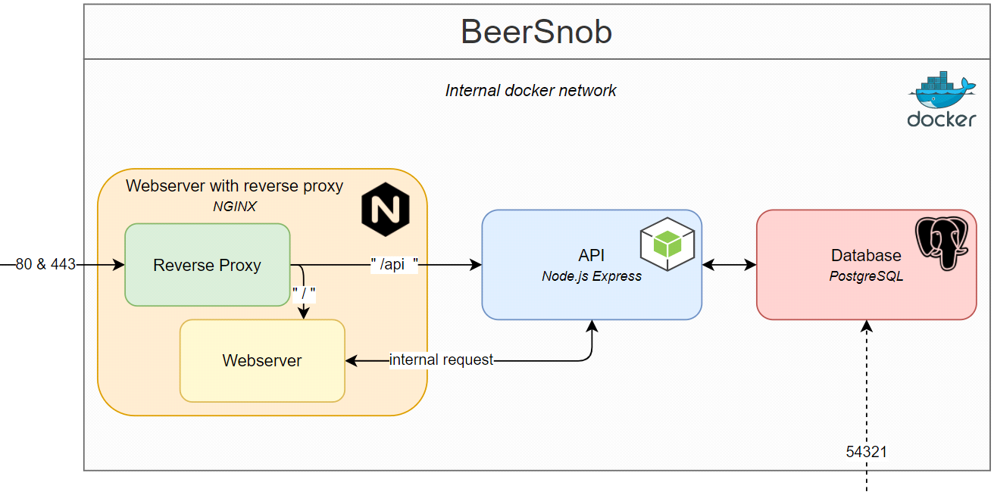

Overview of our goal: our application in Docker (image by [author](http://mikehuls.medium.com/))

So what does this all mean? First thing to notice is that we now have multiple, interconnected services running on our single server. This is very impressive on it’s own but it gets better. Let’s walk through all of the blocks first:

We’ll start with the big **grey block** that’s containing all the others. This is the network in which all of our services (the other blocks) live on our server. Notice that there are just two ways to enter our network; via port 80 (http), port 443 (https) and port 54321 to access the database externally. We’ll get into access later

**Orange block**: this is our webserver and reverse proxy.  
The webserver holds our website-files and makes them available to the world via http and https; the default ports.  
The reverse proxy is responsible for passing through requests. We catch beersnob.com/api for example and pass every request to the API service in the blue block, other requests go to the webserver.

**Blue block**: our API is responsible for communication between our webserver and the database. Notice that our webserver can perform requests internally; it doesn’t have to call beersnob.com/api/users for example, it can just call the API container directly with apicontainer/users. This offers flexibility and security.

**Red block**: our database that holds all of our data. Notice two things: there is no connection between our webserver and our database; this is all handled via our API. The second thing is that we can access our database from outside the network. This way we can connect to our database in our database management system (PgAdmin e.g.) and work with the data in our database, export it, import data or make stored procedures for example.

3. Creating the docker-compose.yml

We’re going to define all of our servcies and connections in the docker-compose.yml. Check it out below.

In these mere 50 odd lines of code, Docker orchestrates all containers for our entire application. I can imagine, though, that if you’re unfamiliar with Compose it can seem a little bit confusing so let’s walk through the lines. You’ll see that three services are defined; a database, API and webserver. Let’s go through it one by one.

3.1 Database

Check out the configuration of our database container.



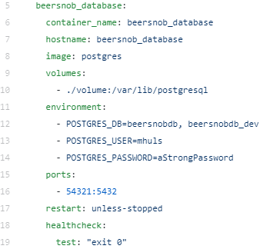

Service 1: our application’s database

**container_name**: the name we’ll give to our container. Otherwise a random name will be generated

**hostname**: our container will be accessible on the internal network by this hostname. See this as a sort of domain name ([http://beersnob_database](http://beersnob_database/))

**image**: The software that’s going to get installed in the container. In this case it’s the default Postgres image.

**volumes**: volumes are a way to persist data. When we run this image Postgres gets built in the container. We can then put some data in it. If we remove our container our data is gone as well. Volumes allow us to copy the data in our container to our host. Volumes can also be shared by multiple containers. We can also put our source code in volumes so that when we edit the code on our host, the change gets reflected in the container.

**environment**: These are settings for the container. Here we provide two database names, a user and a password so that Postgres can setup our first databases and our first user

**ports**: by default we cannot reach the database in our container. With this port mapping we can patch through access to the database. If we go to localhost:54321 then the host (where Docker runs) puts the connection through to the network within the container to port 5432; which is where our database runs.

**restart**: What happens if our container crashes? We chose ‘unless-stopped’ but we can also ‘always’ restart, don’t restart (‘no’) and restart ‘on-failure’.

3.2 API

We’ll now go through all configurations for our API, skipping the parts we’ve already covered in the database.

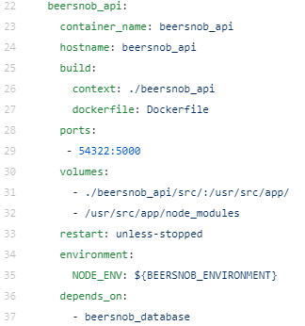

**build**: In the database we could just pass an image but when it comes to our API we have to do a little extra work. We refer to a folder called “beersnob_api” with the **context** that contains a dockerfile. In this dockerfile we pull a Node-image, install our dependencies and copy our source code into the container.

**volumes**: You see here that we mirror our source code (in ./beersnob_api/src) into the container. If we change anything in our source code in the host, the change is reflected in the container once we re-run it.

**environment**: Our source-code in node needs to be called with an environment variable (either ‘development’ or ‘production’). This is done with an env-file. More on this in a later part of this article.

**depends_on**: start this API-container once the database is up and running.

3.3 Webserver

The webserver will hold the source code for our website (via volumes). Also notice that we map 2 ports in this container: 80 and 443 (http and https).

3.4 The internal container network

Notice that our containerized app now has its own internal network that our services can use to communicate with each other. Imagine we host our app on beersnob.com. Our website doesn’t have to call <http://beersnob.com/api/users> to request user information from the database, instead it can just use the internal hostname of the API (<http://beersnob_api/api/users>).

Our containers are like blocks that stack on to each other (image by [Suzy Hazelwood](https://www.pexels.com/@suzyhazelwood) on Pexels)

4. Env files

Remember the environment files from earlier in this article? Check out line 33 in the docker-compose.yml; it says NODE_ENV=${BEERSNOB_ENVIRONMENT}. This means that we have to provide the BEERSNOB_ENVIRONMENT variable with an env file.

5. Spinning up our containers

Let’s spin up our containers! Don’t worry about copying the compose file or not having all data; check out [**this link**](https://github.com/mike-huls/beersnob_compose) where you can clone the repository and spin up the containers on your machine.

Navigate to the folder that contains the docker-compose.yml and call docker --env-file ./config/.env_dev up. That’s it! This command supplied environment variables, copied our source code, installed our dependencies, created all images and finally spun up our network and containers. Let’s test it out!

* Go to [localhost](http://localhost:54322/api/test):54322/api/test to test the API.
* Go to localhost or localhost:80 to test the webserver
* Use a database management system (like PgAdmin) to connect to our database on localhost:54321 with the credentials from the docker-compose.yml (line 12–14)

Our containers working together like the gears in this clock (image by [Felix Mittermeier](https://www.pexels.com/@felixmittermeier) on Pexels)

**Conclusion**

As we have seen Compose adds a lot of automation, flexibility and standardization. Personally, I think it’s amazing to work with infrastructure in such an automated way. We keep our services decoupled, our source code isolated and our infrastructure version controlled. Hopefully this article helps you a bit with containerizing your application.

Docker is an in-demand, DevOps technology sought after in the tech industry. This powerful tool allows you to set up and deploy applications using containers. With the consistent environment of Docker, the development lifecycle of applications is easy and seamless. Docker Compose, a more advanced Docker tool, can be used to simplify your workflow.

In this article, we will refresh your knowledge of Docker and show you how to get started with Docker Compose. To be most successful with this article, you should already have some experience with Docker.

*If you’re new to DevOps, check out our*[*beginner’s guide to Docker and Kubernetes*](https://www.educative.io/blog/docker-kubernetes-beginners-guide)*before proceeding with this tutorial.*

**Today, we will go over:**

* [Brief refresher on Docker](https://www.educative.io/blog/docker-compose-tutorial)
* [Fundamentals of Docker](https://www.educative.io/blog/docker-compose-tutorial)
* [Getting started with Docker Compose](https://www.educative.io/blog/docker-compose-tutorial)
* [What to learn next](https://www.educative.io/blog/docker-compose-tutorial)
* [Wrapping up and resources](https://www.educative.io/blog/docker-compose-tutorial)

*Learn advanced Docker and Docker Compose.*

**Learn the fundamentals of Docker with hands-on practice.**

[**Working with Containers: Docker HYPERLINK "https://www.educative.io/courses/working-with-containers-docker-docker-compose"& HYPERLINK "https://www.educative.io/courses/working-with-containers-docker-docker-compose" Docker Compose**](https://www.educative.io/courses/working-with-containers-docker-docker-compose)

**Brief refresher on Docker**

Docker is an open-source containerization tool used to simplify the creation and deployment of applications by using the concept of **containers**. Containers allow us to package all the parts of an application and deploy it as one entity.

This tool makes it easy for different developers to work on the same project in the same environment without any dependencies or OS issues. Docker is sort of like a virtual machine, but Docker enables applications to access the same Linux kernel.

Docker offers many advantages for developers and DevOps teams. Docker…

* is highly demanded by companies large and small
* offers isolation from the main system
* simplifies configuration
* provides access to thousands of configured images with Docker Hub
* supports many CI tools like Travis and Jenkins
* allows developers to focus just on writing code
* simplifies deployment management for operations teams

Docker is commonly used alongside **Kubernetes**, a powerful container management tool that automates the deployment of your Docker containers. While Docker is used to isolate, pack, and ship your application into containers, Kubernetes is like the container scheduler for deploying and scaling the application.

The two technologies are designed to work together and make app deployment a breeze.

**Fundamentals of Docker**

Before diving into advanced Docker concepts, like Docker Compose, we want to make sure to refresh the fundamentals of Docker as a whole. Let’s define and explore the basics of Docker.

Docker Architecture

The Docker Architecture is made of layers, as we will discuss below. The bottom layer is the physical server that we use to host virtual machines. This is the same as a traditional virtualization architecture.

The second layer is the Host OS, which is the base machine (i.e. Windows or Linux). Next, is the Docker Engine, which we use to run the operating system. Above that is are the Apps which run as Docker containers. Those Docker Objects are made up of images and containers.

Containers and images

The basic structure of Docker relies on **images** and **containers**. Think of images and containers as two different states of the same underlying concept. A container is like an object, and an image is like its class.

Think of a container as an isolated system that contains everything needed to run a certain application. It is an instance of an image that simulates the required environment. Below is an example command when we run a ubuntu Docker container:

docker run -i -t ubuntu /bin/bash

Images, on the other hand, are used to start-up containers. From running containers, we can get images, which can be composed together to form a system-agnostic way of packaging applications.

Images can be pre-built, retrieved from registries, created from already existing ones, or combined together via a common network.

Dockerfiles

Dockerfiles are how we containerize our application, or how we build a new container from an already pre-built image and add custom logic to start our application. From a Dockerfile, we use the Docker build command to create an image.

Think of a Dockerfile as a text document that contains the commands we call on the command line to build an image.

Below is an example of a Dockerfile:

FROM python:3  
   
WORKDIR /usr/src/app  
   
COPY requirements.txt ./  
RUN pip install --no-cache-dir -r requirements.txt  
   
COPY . .  
   
CMD [ "python", "./your-daemon-or-script.py" ]

Layers

A Dockerfile works in layers. These are the building blocks of Docker. The first layer starts with the FROMkeyword and defines which pre-built image we will use build an image. We can then define user permissions and startup scripts.

In Docker, a container is an image with a readable layer build on top of a read-only layers. These layer are called intermediate images, and they are generated when we execute the commands in our Dockerfile during the build stage.

Docker Hub

Docker Hub is a Docker Registry that provides unlimited storage of public images and paid plans for hosting private images. A public image may be accessed by anyone. You can publish and access images on Docker Hub once you make an account.

You can do this using the docker build command or docker tags to generate an image ID. You can publish an image on Docker Hub using the following commands:

docker login  
docker push learnbook/webserver

That was just an overview of the fundamentals of Docker before we move onto move advanced concepts. Keep in mind that there’s a lot more to Docker than what we discussed above.

From Simran Deep Thakral to Everyone 04:33 PM

<https://container-registry.oracle.com/>

From Shrey Garg to Everyone 04:33 PM

<https://catalog.redhat.com/software/containers/search>

From Manav Chirania to Everyone 04:33 PM

<https://catalog.redhat.com/software/containers/search>

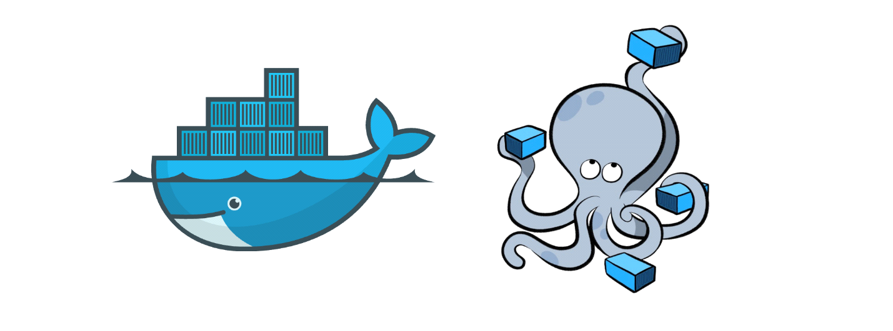

Docker rule:

1. Any changes to the state happens to the container and not the image

2. Stopping and Starting the container persist changes to the container

apt update && apt install -y curl

exit

docker stop <container-name>

docker start <container-name>

docker exec -it <container-name> /bin/bash

curl

3. Removing the container loses the changes to the state

docker stop <container-name>

docker rm <container-name>

4. If you want to persist the changes in the state forever then use docker commit

docker commit <container-name>

5. Network rule will persist if the containers are stopped/started but will not persist when the containers are removed

**Getting started with Docker Compose**

Now for the advanced stuff. **Docker Compose** is a Docker tool used to define and run multi-container applications. With Compose, you use a YAML file to configure your application’s services and create all the app’s services from that configuration.

Think of docker-compose as an **automated multi-container workflow.** Compose is an excellent tool for development, testing, CI workflows, and staging environments. According to the Docker documentation, the most popular features of Docker Compose are:

* Multiple isolated environments on a single host
* Preserve volume data when containers are created
* Only recreate containers that have changed
* Variables and moving a composition between environments
* Orchestrate multiple containers that work together

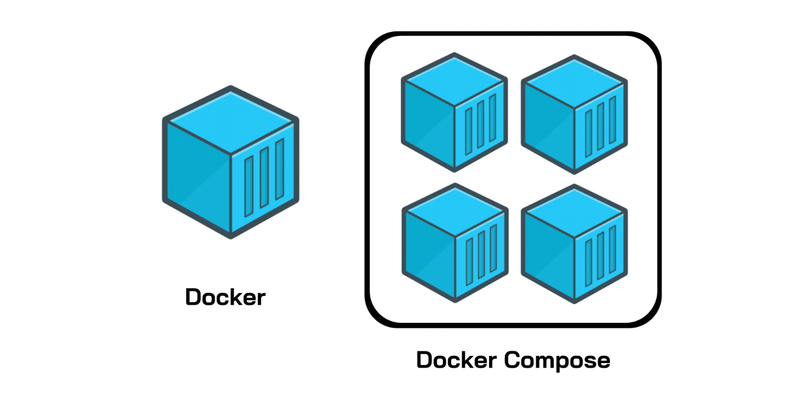

***Enjoying the article?****Scroll down to*[*sign up*](https://www.educative.io/blog/blog-newsletter-annoucement)*for our free, bi-monthly newsletter.*

How to use and install Docker Compose

Compose uses the Docker Engine, so you’ll need to have the Docker Engine installed on your device. You can run Compose on Windows, Mac, and 64-bit Linux. Installing Docker Compose is actually quite easy.

On desktop systems, such as Docker Desktop for Mac and Windows, Docker Compose is already included. No additional steps are needed. On Linux systems, you’ll need to:

* Install the Docker Engine
* Run the following command to download Docker Compose

sudo curl -L "[https://github.com/docker/compose/releases/download/1.26.2/docker-compose-$(uname -s)-$(uname -m)](https://github.com/docker/compose/releases/download/1.26.2/docker-compose-$(uname%A0-s)-$(uname%A0-m))" -o /usr/local/bin/docker-compose

* Apply permissions to the binary, like so:

sudo chmod +x /usr/local/bin/docker-compose

* Test the installation to check it worked properly

$ docker-compose --version  
docker-compose version 1.26.2, build 1110ad01

Regardless of how you chose to install it, once you have Docker Compose downloaded and running properly, you can start using it with your Dockerfiles. This process requires three basic steps:

* Define your app’s environment using a Dockerfile. This way, it can be reproduced.
* Define the services for your app in a docker-compose.yml file. This way, they can run in an isolated environment.
* Run docker-compose to start your app.

You can easily add Docker Compose to a pre-existing project. If you already have some Dockerfiles, add Docker Compose files by opening the Command Palette. Use the **Docker: Docker Compose Files to the Workspace** command, and, when promoted, choose the Dockerfiles you want to include.

You can also add Docker Compose files to your workspace when you add a Dockerfile. Similarly, open the Command Palette and use the **Docker: Add Docker Files to Workspace** command.

You’ll then be asked if you want to add any Docker Compose files. In both cases, Compose extension will add the docker-compose.yml file to your workspace.

Docker Compose file structure

Now that we know how to download Docker Compose, we need to understand how Compose files work. It’s actually simpler than it seems. In short, Docker Compose files work by applying mutiple commands that are declared within a single docker-compose.yml configuration file.

The basic structure of a Docker Compose YAML file looks like this:

version: 'X'

services:

  web:

    build: .

    ports:

     - "5000:5000"

    volumes:

     - .:/code

  redis:

    image: redis

Now, let’s look at real-world example of a Docker Compose file and break it down step-by-step to understand all of this better. Note that all the clauses and keywords in this example are commonly used keywords and industry standard.

With just these, you can start a development workflow. There are some more advanced keywords that you can use in production, but for now, let’s just get started with the necessary clauses.

    ports:

      - "5000:5000"

    # Mount volume

    volumes:

      - "/usercode/:/code"

    # Link database container to app container

    # for reachability.

    links:

      - "database:backenddb"

  database:

    # image to fetch from docker hub

    image: mysql/mysql-server:5.7

    # Environment variables for startup script

    # container will use these variables

    # to start the container with these define variables.

    environment:

      - "MYSQL_ROOT_PASSWORD=root"

      - "MYSQL_USER=testuser"

      - "MYSQL_PASSWORD=admin123"

      - "MYSQL_DATABASE=backend"

    # Mount init.sql file to automatically run

    # and create tables for us.

    # everything in docker-entrypoint-initdb.d folder

    # is executed as soon as container is up nd running.

    volumes:

      - "/usercode/db/init.sql:/docker-entrypoint-initdb.d/init.sql"

* **version ‘3’:** This denotes that we are using version 3 of Docker Compose, and Docker will provide the appropriate features. At the time of writing this article, version 3.7 is latest version of Compose.
* **services:** This section defines all the different containers we will create. In our example, we have two services, web and database.
* **web:** This is the name of our Flask app service. Docker Compose will create containers with the name we provide.
* **build:** This specifies the location of our Dockerfile, and . represents the directory where the docker-compose.yml file is located.
* **ports:** This is used to map the container’s ports to the host machine.
* **volumes:** This is just like the -v option for mounting disks in Docker. In this example, we attach our code files directory to the containers’ ./code directory. This way, we won’t have to rebuild the images if changes are made.
* **links:** This will link one service to another. For the bridge network, we must specify which container should be accessible to which container using links.
* **image:** If we don’t have a Dockerfile and want to run a service using a pre-built image, we specify the image location using the image clause. Compose will fork a container from that image.
* **environment:** The clause allows us to set up an environment variable in the container. This is the same as the -e argument in Docker when running a container.

Congrats! Now you know a bit about Docker Compose and the necessary parts you’ll need to get started with your workflow.

**Keep the learning going.**

Learn advanced Docker and Docker Compose without scrubbing through videos or documentation. Educative’s text-based courses are easy to skim and feature live coding environments, making learning quick and efficient.

[**Working with Containers: Docker HYPERLINK "https://www.educative.io/courses/working-with-containers-docker-docker-compose"**& HYPERLINK "https://www.educative.io/courses/working-with-containers-docker-docker-compose" Docker Compose](https://www.educative.io/courses/working-with-containers-docker-docker-compose)

Docker Compose commands

Now that we know how to create a docker-compose file, let’s go over the most common Docker Compose commands that we can use with our files. Keep in mind that we will only be discussing the most frequently-used commands.

**docker-compose:** Every Compose command starts with this command. You can also use docker-compose <command> --help to provide additional information about arguments and implementation details.

$ docker-compose --help  
Define and run multi-container applications with Docker.

**docker-compose build:** This command builds images in the docker-compose.yml file. The job of the build command is to get the images ready to create containers, so if a service is using the prebuilt image, it will skip this service.

$ docker-compose build  
database uses an image, skipping  
Building web  
Step 1/11 : FROM python:3.9-rc-buster  
 ---> 2e0edf7d3a8a  
Step 2/11 : RUN apt-get update && apt-get install -y docker.io

**docker-compose images:** This command will list the images you’ve built using the current docker-compose file.

$ docker-compose images  
          Container                  Repository        Tag       Image Id       Size    
--------------------------------------------------------------------------------------  
7001788f31a9_docker_database_1   mysql/mysql-server   5.7      2a6c84ecfcb2   333.9 MB  
docker_database_1                mysql/mysql-server   5.7      2a6c84ecfcb2   333.9 MB  
docker_web_1                     <none>               <none>   d986d824dae4   953 MB

**docker-compose stop:** This command stops the running containers of specified services.

$ docker-compose stop  
Stopping docker_web_1      ... done  
Stopping docker_database_1 ... done

**docker-compose run:** This is similar to the docker run command. It will create containers from images built for the services mentioned in the compose file.

$ docker-compose run web  
Starting 7001788f31a9_docker_database_1 ... done  
 * Serving Flask app "app.py" (lazy loading)  
 * Environment: development  
 * Debug mode: on  
 * Running on <http://0.0.0.0:5000/> (Press CTRL+C to quit)  
 * Restarting with stat  
 * Debugger is active!  
 * Debugger PIN: 116-917-688

**docker-compose up:** This command does the work of the docker-compose build and docker-compose run commands. It builds the images if they are not located locally and starts the containers. If images are already built, it will fork the container directly.

$ docker-compose up  
Creating docker_database_1 ... done  
Creating docker_web_1      ... done  
Attaching to docker_database_1, docker_web_1

**docker-compose ps:** This command list all the containers in the current docker-compose file. They can then either be running or stopped.

$ docker-compose ps  
      Name                 Command             State               Ports           
---------------------------------------------------------------------------------  
docker_database_1   /entrypoint.sh mysqld   Up (healthy)   3306/tcp, 33060/tcp     
docker_web_1        flask run               Up             0.0.0.0:5000->5000/tcp  
   
$ docker-compose ps  
      Name                 Command          State    Ports  
----------------------------------------------------------  
docker_database_1   /entrypoint.sh mysqld   Exit 0          
docker_web_1        flask run               Exit 0

**docker-compose down:** This command is similar to the docker system prune command. However, in Compose, it stops all the services and cleans up the containers, networks, and images.

$ docker-compose down  
Removing docker_web_1      ... done  
Removing docker_database_1 ... done  
Removing network docker_default  
(django-tuts) Venkateshs-MacBook-Air:Docker venkateshachintalwar$ docker-compose images  
Container   Repository   Tag   Image Id   Size  
----------------------------------------------  
(django-tuts) Venkateshs-MacBook-Air:Docker venkateshachintalwar$ docker-compose ps  
Name   Command   State   Ports  
------------------------------

Congrats! You’ve now learned most of the basic commands for Docker Compose. Why stop there? Check out the [documentation](https://docs.docker.com/compose/reference/) of other commands and keep learning!

Kubernetes is open source container orchestration tool by Google

Thus, it manages Docker or any other containers hundreds of them in different environments like physical, virtual, cloud or hybrid environments.

Managing 1000 of containers across environments using scripts became difficult hence Kubernetes came to help.

What features does Kubernetes offer?

1. High availability (No downtime)

2. Scalability (High performance)

3. Disaster Recovery (backup & restore)

Each microservice is now a separate application with its own development and release cycle.

The dependencies of different microservices will inevitably diverge over time. One

microservice requires one version of a library, while another microservice requires another,

possibly incompatible, version of the same library. Running the two applications in the same

operating system becomes difficult

Any company that wants to be able to move its applications from one provider to another

will have to make additional, initially unnecessary efforts to abstract the infrastructure and

APIs of the underlying cloud provider from the applications. This requires resources that

could otherwise be focused on building the primary business logic.

Kubernetes has also helped in this respect. The popularity of Kubernetes has forced all

major cloud providers to integrate Kubernetes into their offerings. Customers can now deploy

applications to any cloud provider through a standard set of APIs provided by Kubernetes.



Non-production clusters can use a single master node, but highly available clusters use at

least three physical master nodes to host the Control Plane. The number of worker nodes

depends on the number of applications you’ll deploy.



1.2.2 The benefits of using Kubernetes

Next:

A more complex option is to run Kubernetes on-premises, but also allow it to spill over into

the cloud. It’s possible to configure Kubernetes to provision additional nodes in the cloud if

you exceed the capacity of your own data center. This way, you get the best of both worlds.

Kubernetes components

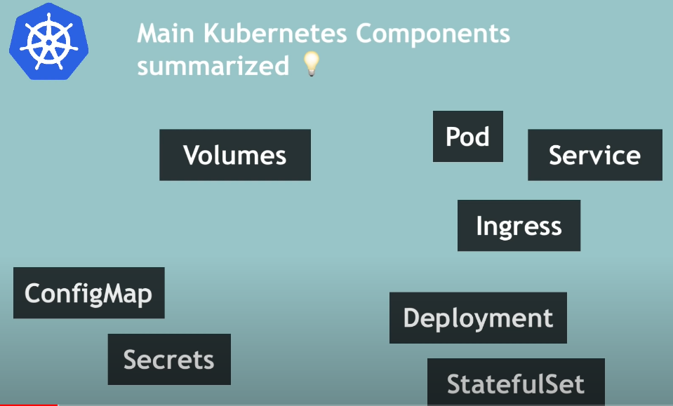

Worker Node architecture:

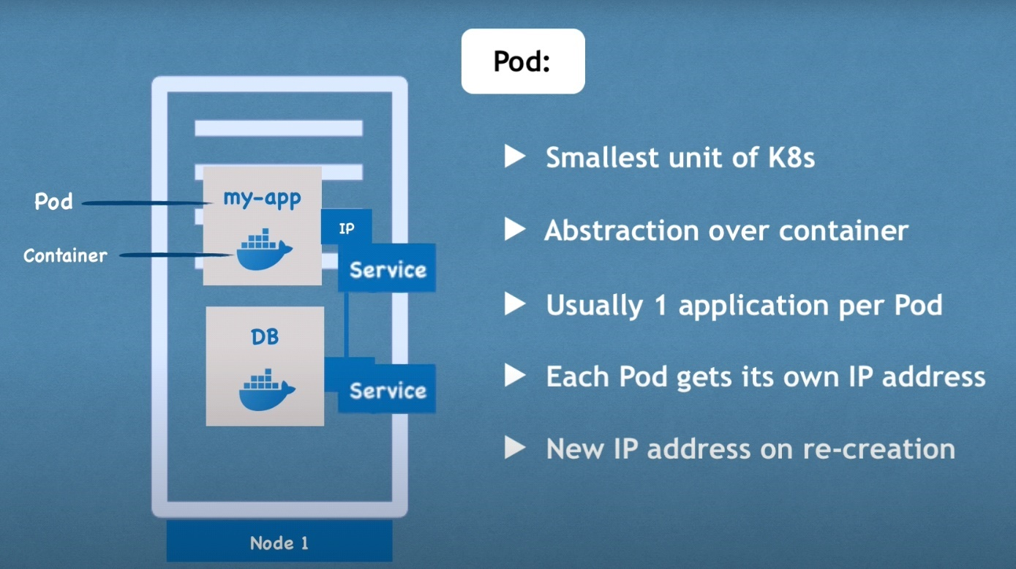

Each POD gets its own IP address (which is internal and not public and meant to communicate with each other like nodejs app and db PODs) and not the container.

Challenge: If the DB POD is destroyed and gets recreated it will get a new IP but that will break the communication between the two PODs.

Solution: use "service" as the service is a component different from the POD. Thus, the service IP/DNS name will remain same/intact even if the POD is recreated.

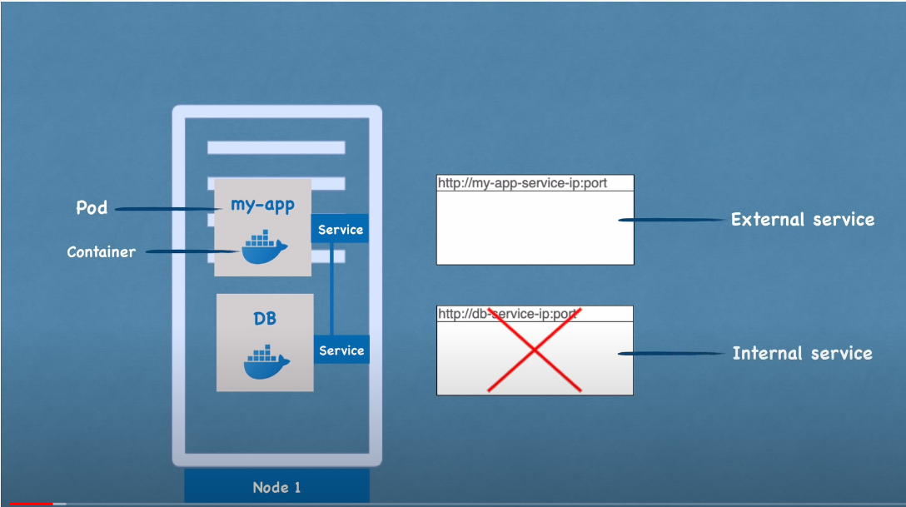

Service architecture:

Challenge: The application has to be accessed using a decent/practical URL and not "IP:PORT"

Solution: Use Ingress

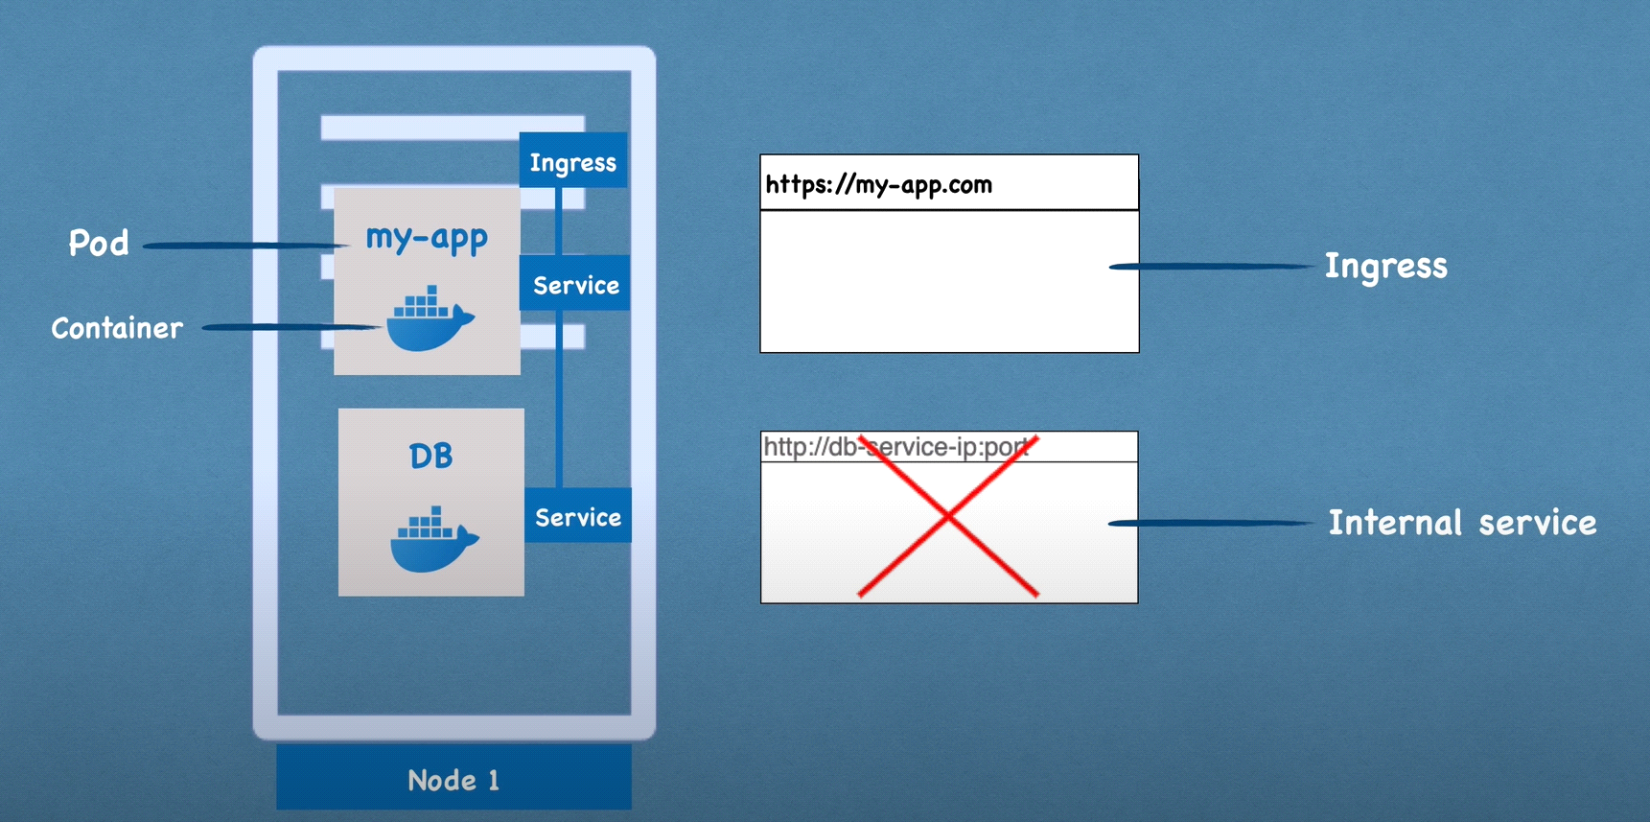

ConfigMap & Secret:

Challenge:

service name "mongo-db-service" with endpoint DB url as <http://dbhost5:1521>

service name "mongo-db" with endpoint DB url as <http://dbhost2:1524>

The service-name for database endpoint as mentioned in the "my-app" i.e "mongo-db-service" solves the changing POD issue (service name remains intact) but the end-point URL of DB is mentioned in the build Image of "my-app" and this endpoint URL may change then we will have to rebuild "my-app", push & finally pull the new image to POD and recreate the whole thing.

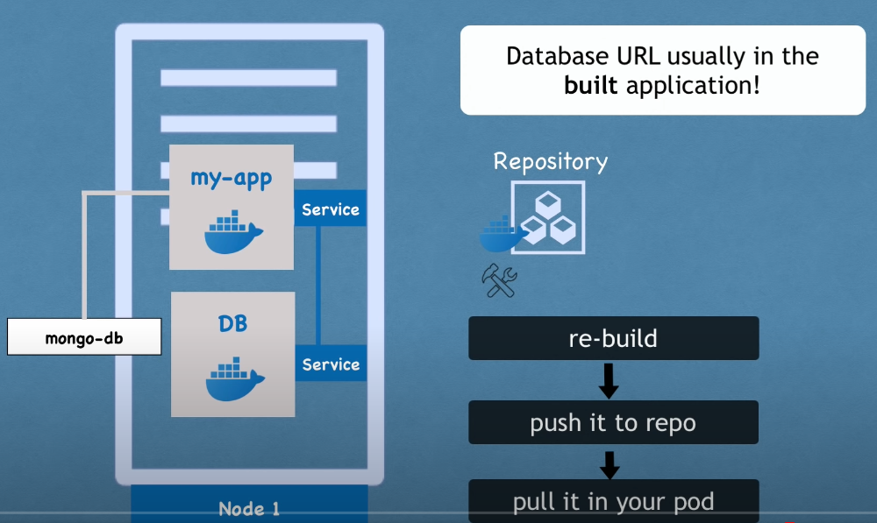

Solution: Use configmap and secrets and lookup from "my-app" using environment variables or properties file.

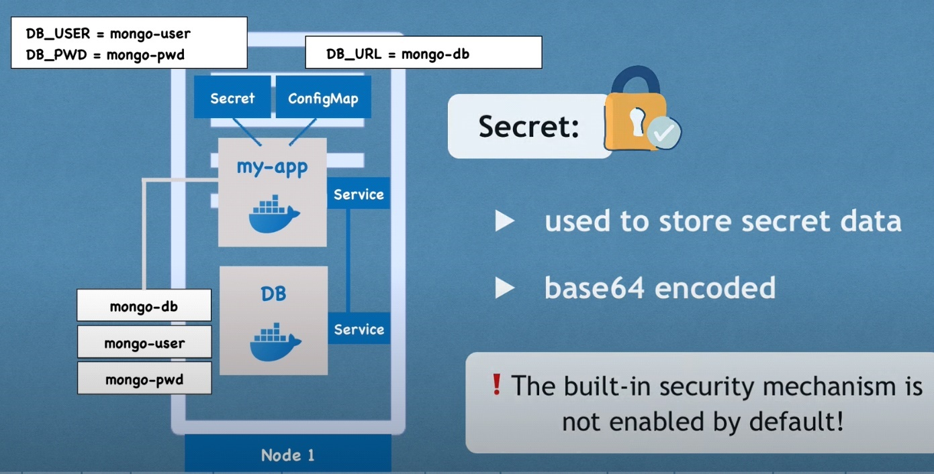

Kubernetes volumes:

Challenge: Log data will be lost if “my-app” POD is restarted or database data will be lost if “DB” pod gets restarted.

Rule: K8s will never ever manage any data persistence

Solution: Use volumes which is physical storage or s3 cloud that is on the (local) same host as the k8s cluster or even (remote) outside the k8s cluster and it attaches itself to the POD.

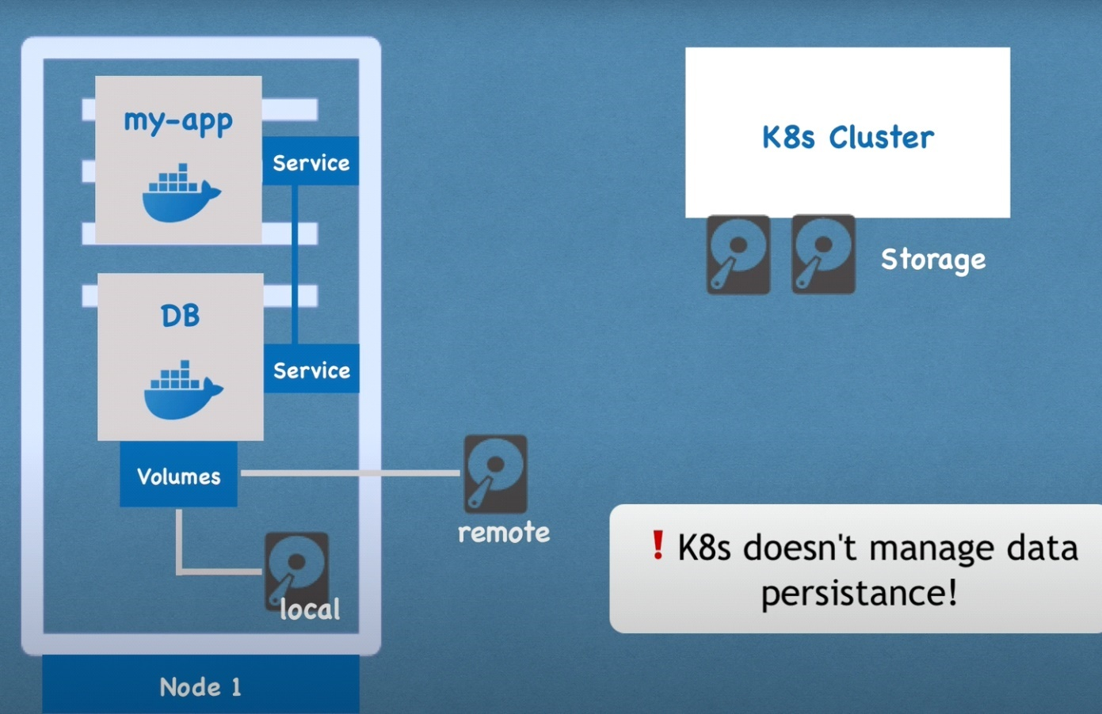

Node replication:

Challenge: What if the single “my-app” POD goes down?

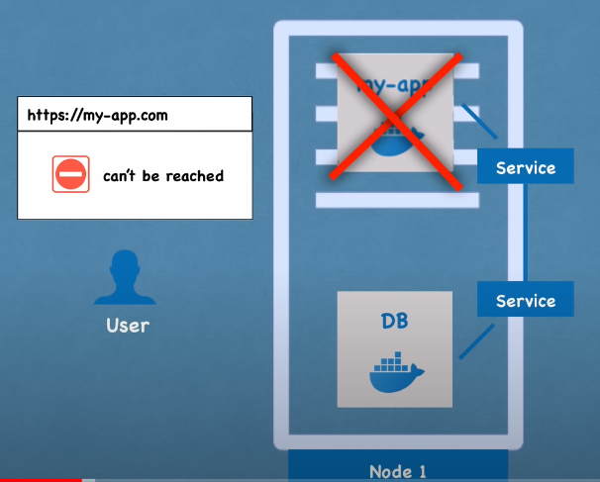

Solution: Replicate the pods and connect them using service that provides permanent IP & load balancing

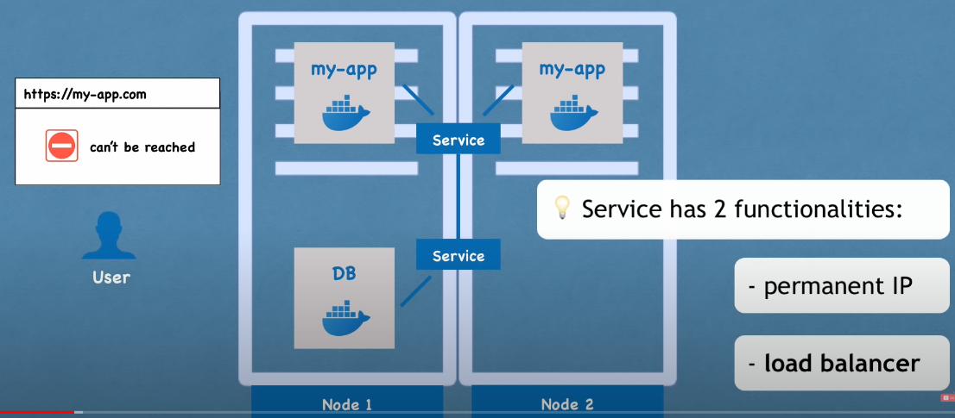

Challenge: How do you replicate PODs?

Solution: using a component called “Deployment” where you will mention the number of replicas for any POD.

Summary: Deployment is abstraction over PODs and PODs is abstraction over “Containers”

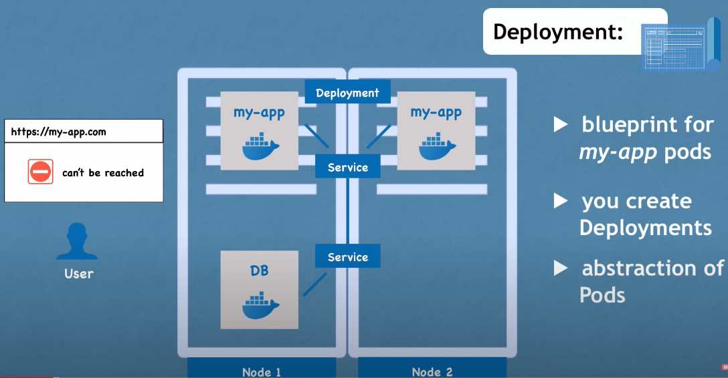

Challenge: While “service” will help forward the request to second “my-app” POD if the first one dies

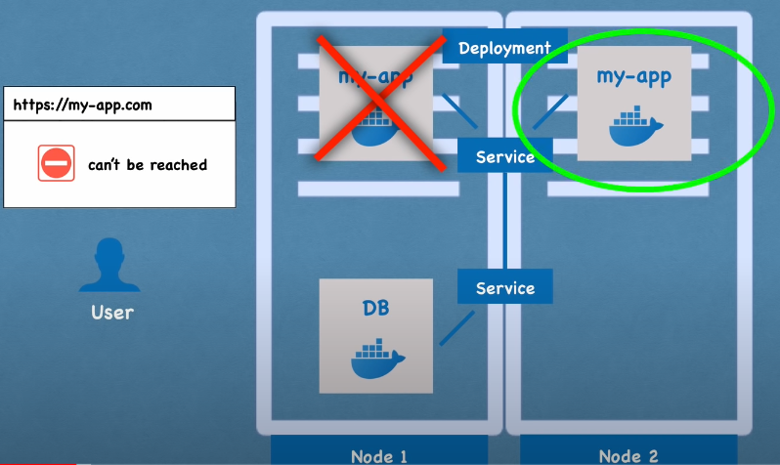

Same is not true about “DB” PODS as it is stateful i.e persists data which means that we need a mechanism to know which PODs of the many DB PODs are performing what changes to the state of the Database.

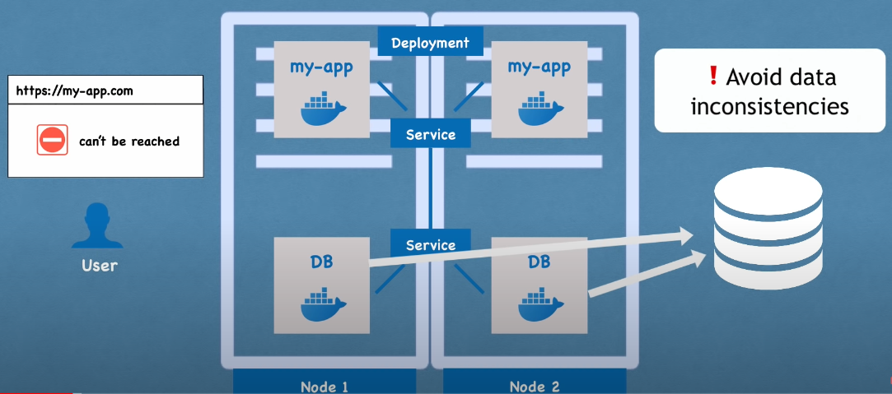

Solution: The solution is to use component “StatefulSet” for stateful apps like logging and Databases

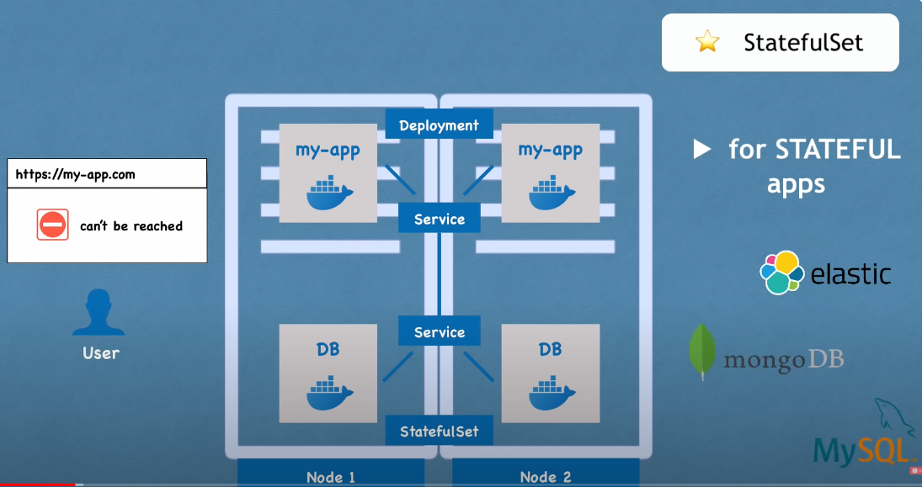

Summary: Difference between “StatefulSet” & “Deployment” is below:

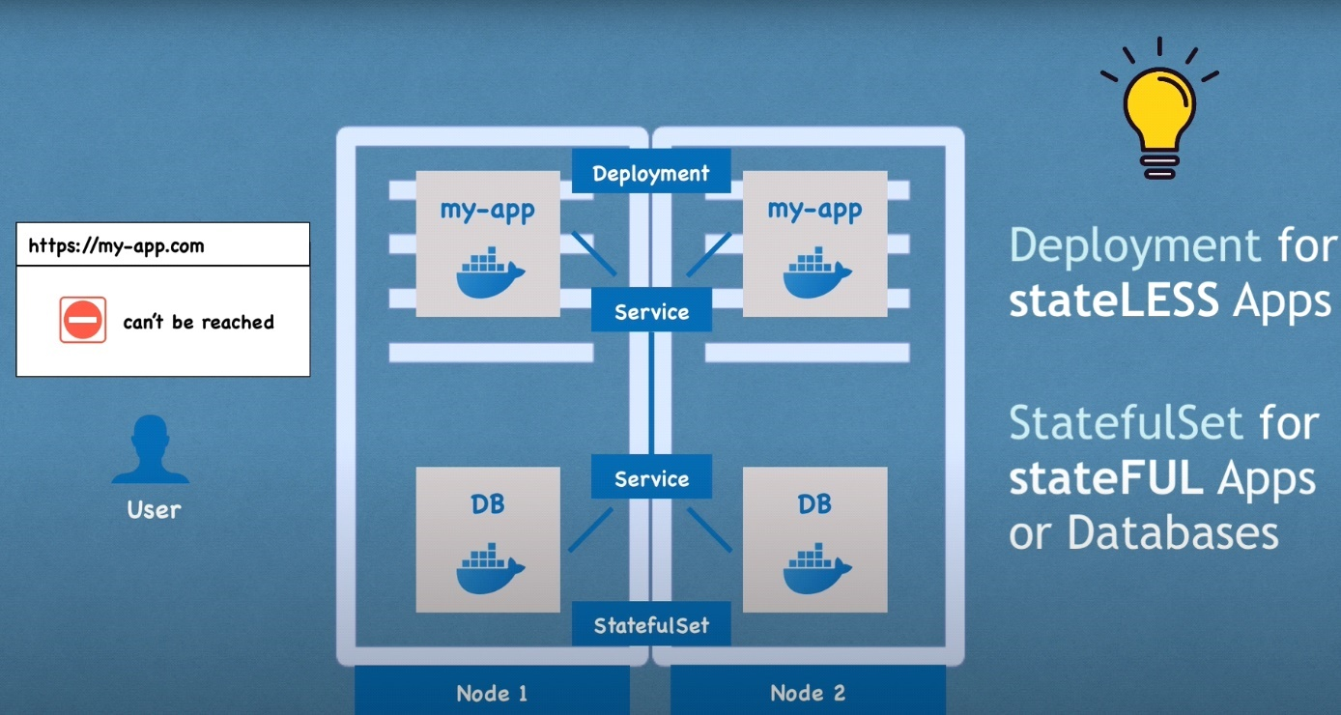

Suggestion: Due to the complexity of setting up “StatefulSet” it is recommended instead to keep/host the databases outside the Kubernetes (world) cluster.

Thus, now even if the entire node and not just the POD crashes we will still have availability of the services:

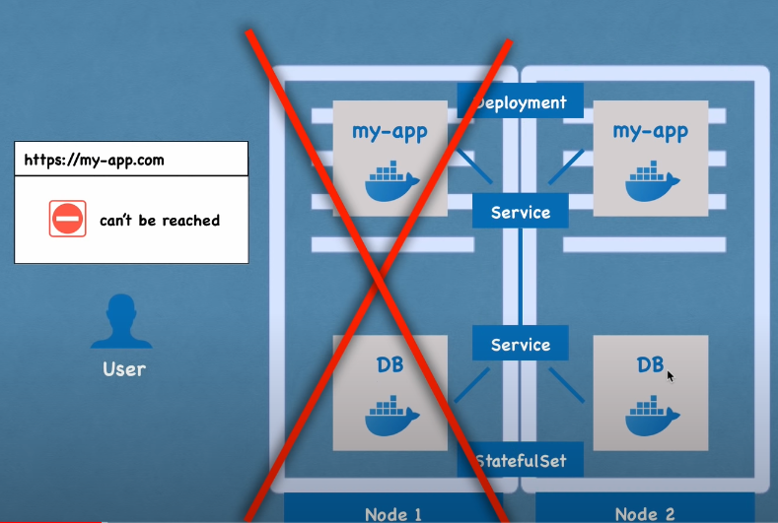

Kubernetes architecture:

Nodes are the actual machines.

K8s has 2 categories of nodes “Master” and “Worker”

Worker Node: Has 3 processes that run on every Worker Node.

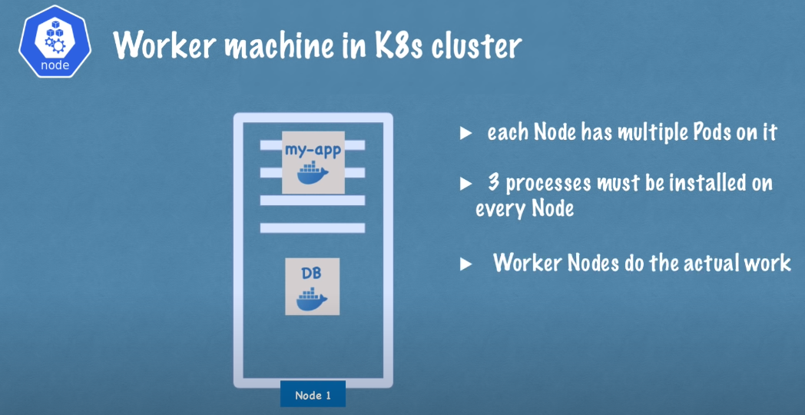

Ignore below for now:

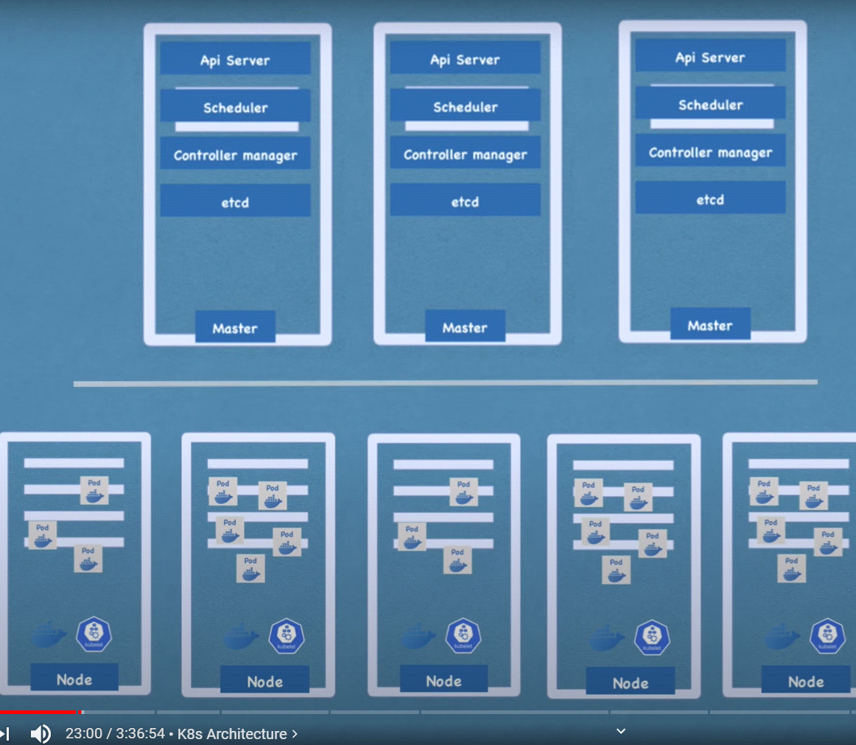

Kubelet:

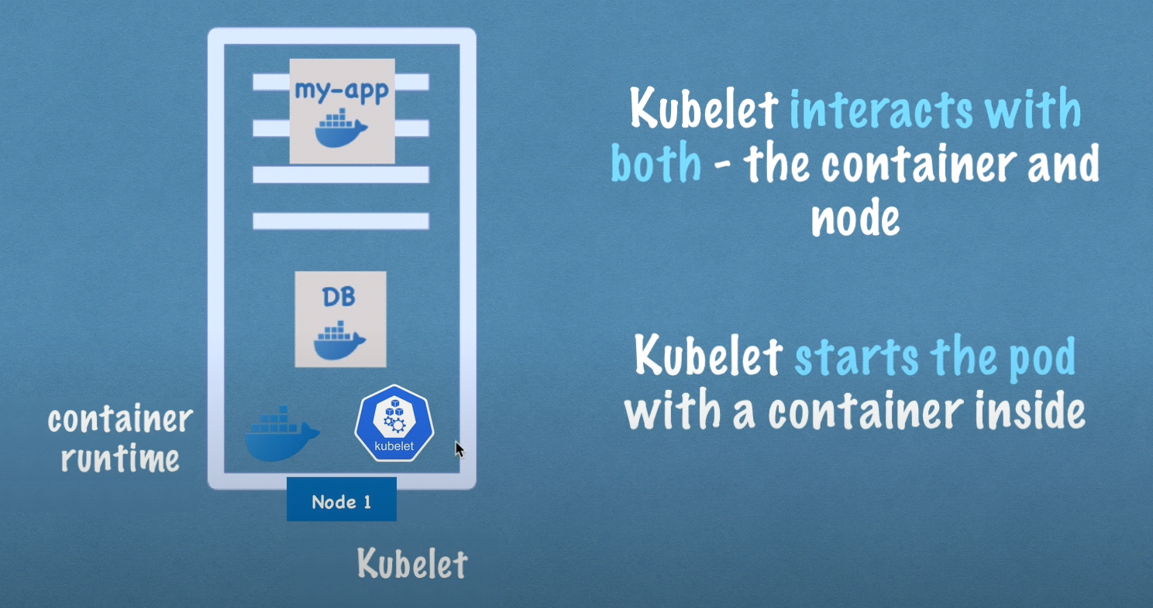

Kubelet also assigns resources from the node to the container like CPU, RAM & storage

Kubernetes cluster: What must be installed:

Question: When you have “service” i.e “DB Service” why do we need Kube Proxy?

Kube-Proxy makes intelligent decisions like forward the DB request to the “local” DB POD (see diagram below) or to a POD with more resources less loaded, thus avoiding “Network” overhead.

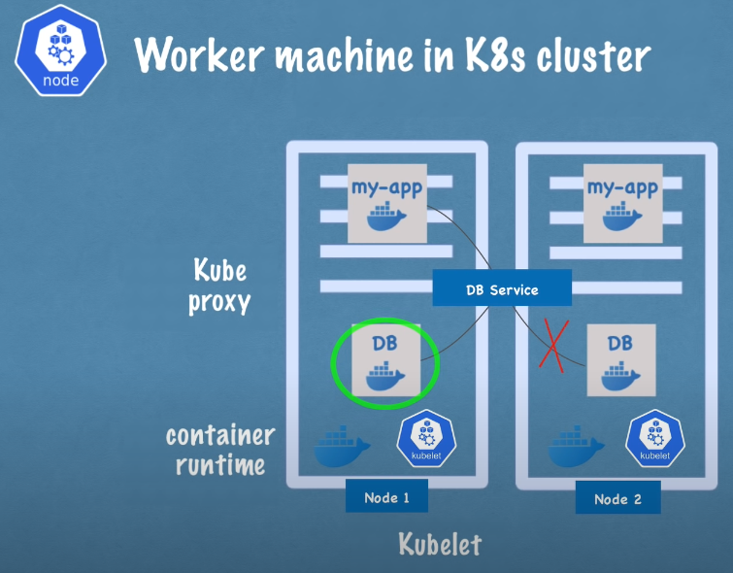

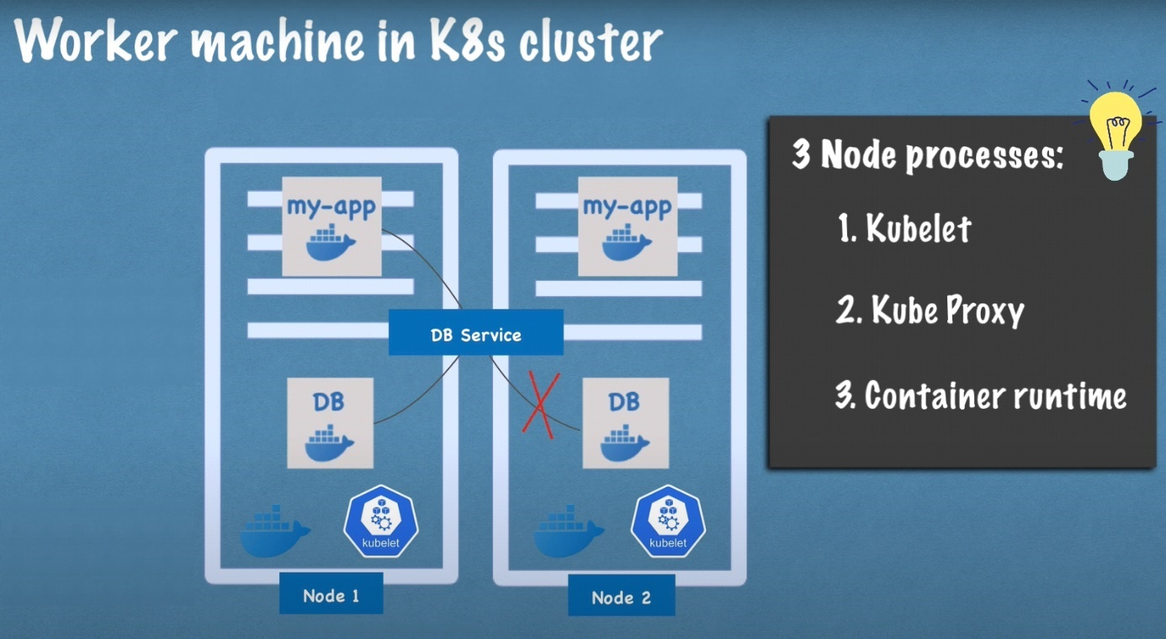

Question: How do we interact & manage i.e. answer the below questions on Worker node of k8s cluster?

Answer: All these managing processes are done by master node.

Master node processes: Has 4 processes that run on every Master Node.

First: API Server

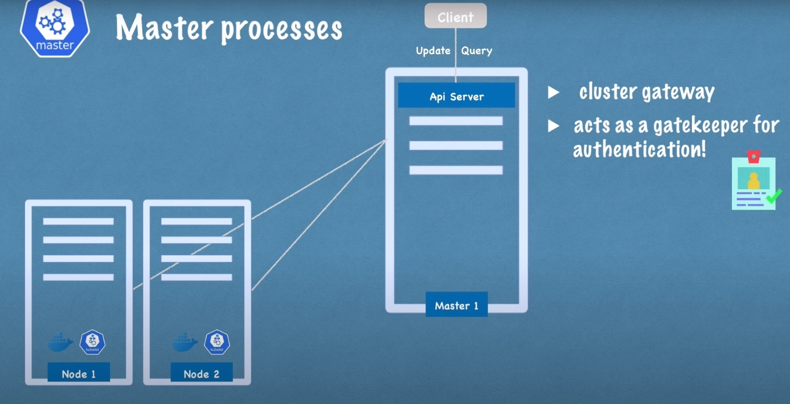

Query can be UI, command-line or using REST APIs.

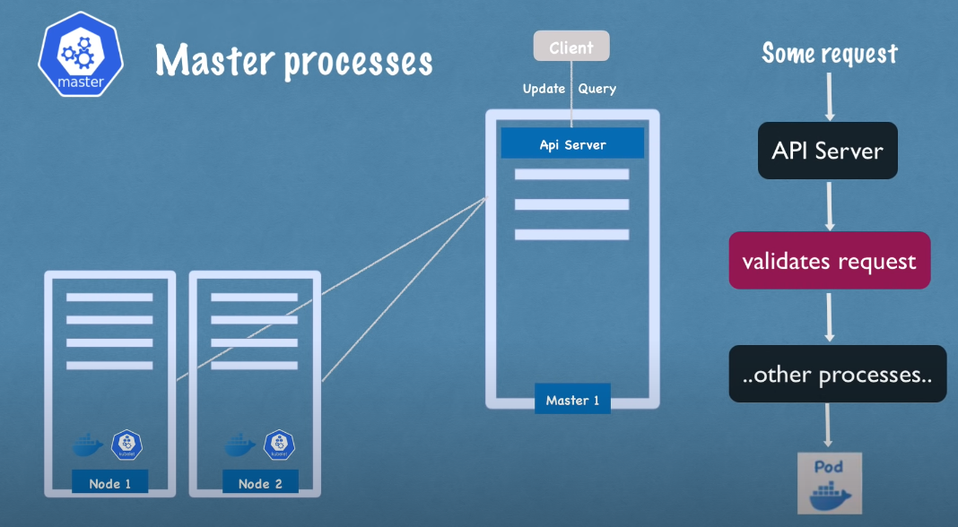

Note: Important for security as API server is the only 1 entry point into the cluster.

2. Scheduler:

Based on the workload will decide one of the nodes to bring up the POD.

The Kubelet based on the decision of the scheduler is the one to actually start the POD

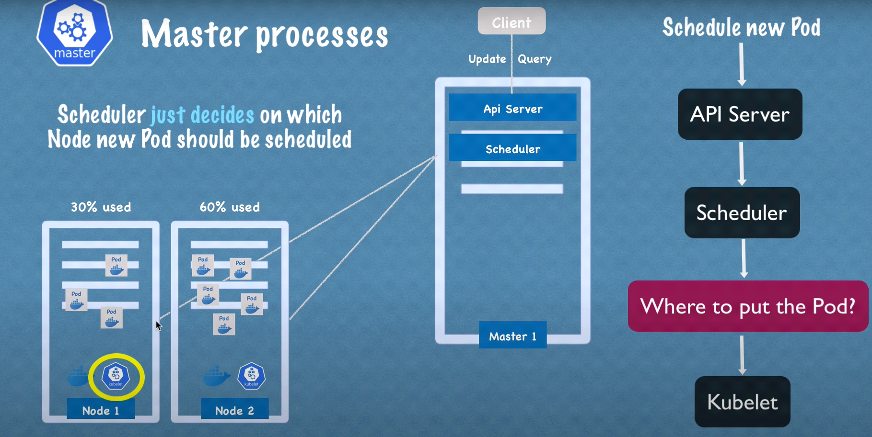

3. Controller Manager: Detect the changes of state of POD in the K8s cluster like crashing of PODs and tries to recover the state of the cluster.

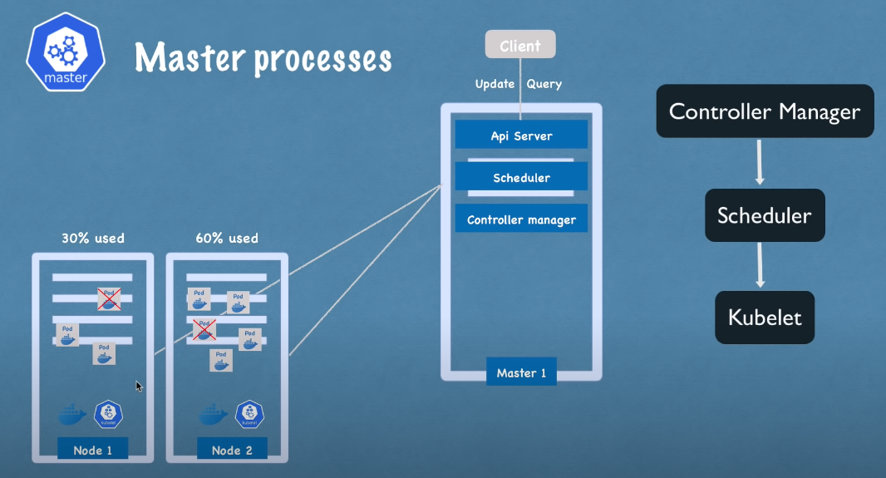

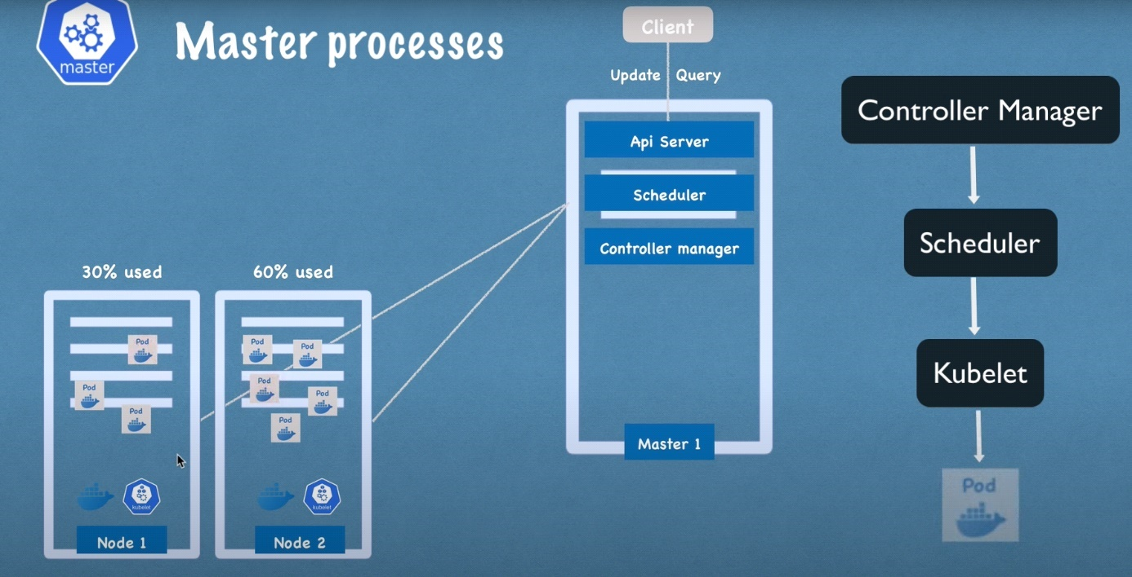

4: etcd: It is the key: value pair of a cluster state.

Any change in the state of the cluster gets updated in the etcd

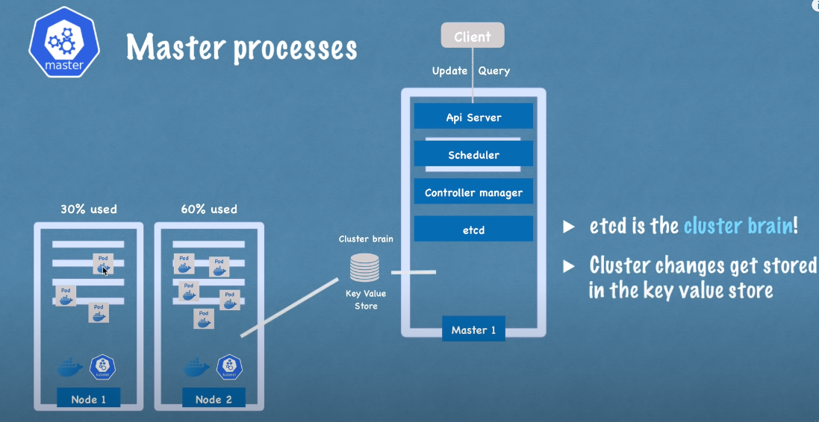

Note: the API Server, Scheduler & Controller Manager works using the data stored by the etcd to get answers to the below.

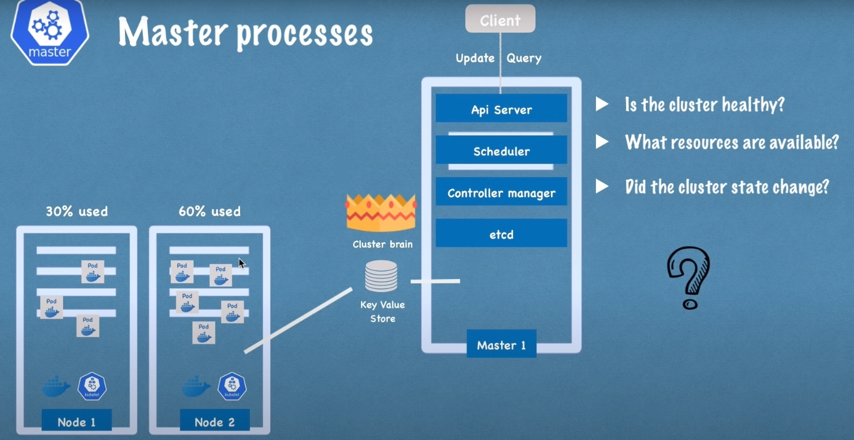

In summary etcd has data to help master processes communicate with the worker processes

Example of Kubernetes Cluster Setup:

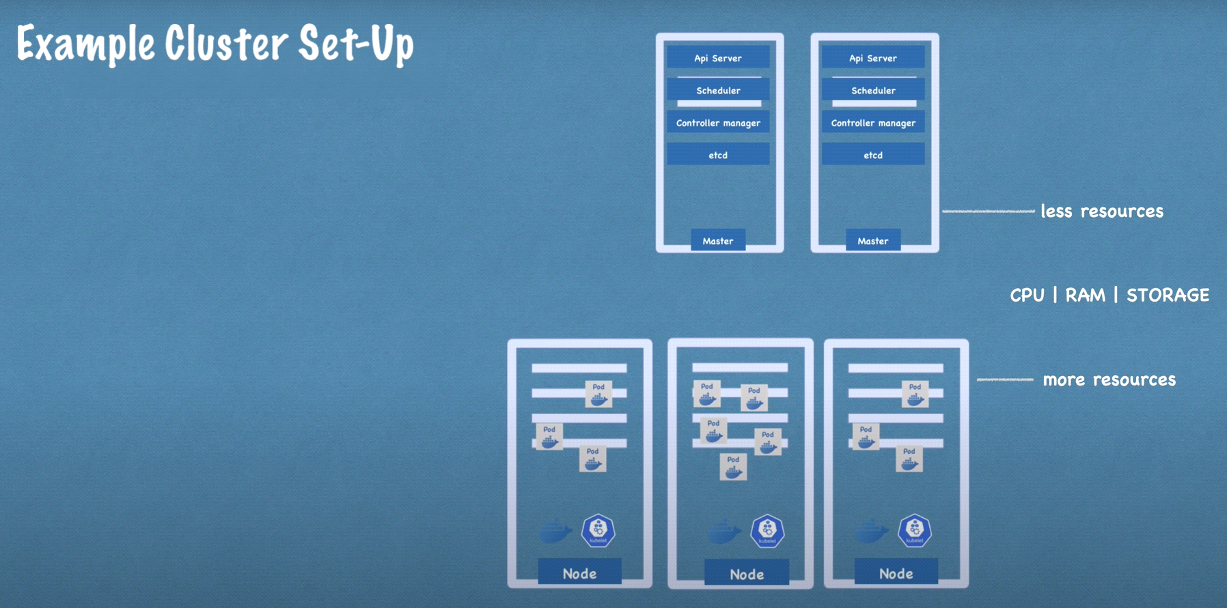

Test Cluster Setup on Local using minikube:

Let’s consider real production setup as below:

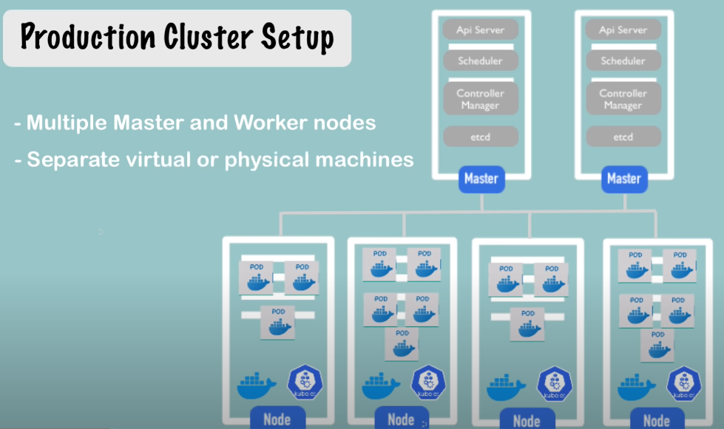

We do not have several nodes hence accommodating all on one node.

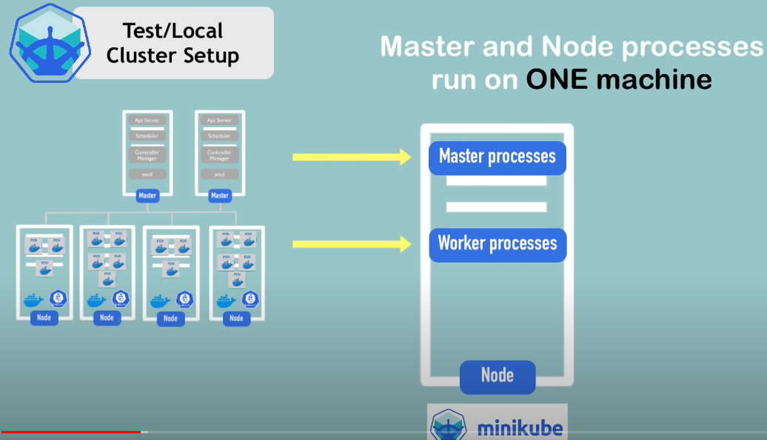

Docker will be preinstalled.

Everything will be hosted on a single virtual box or hypervisor.

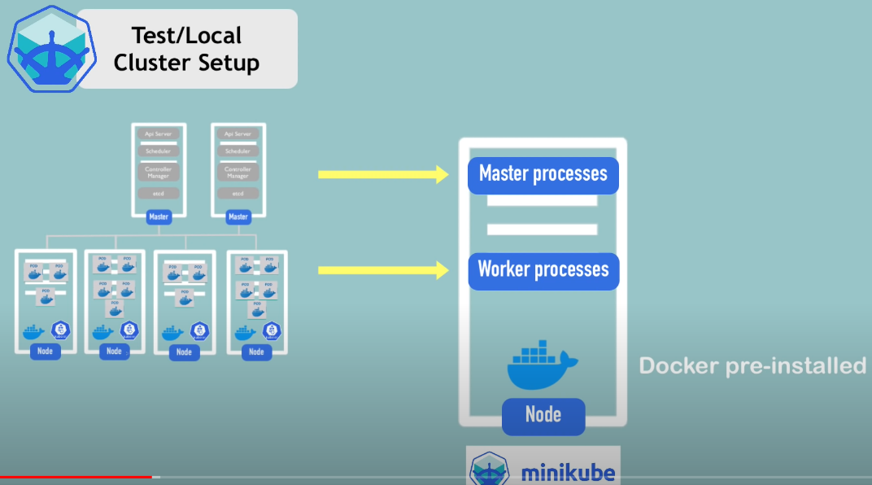

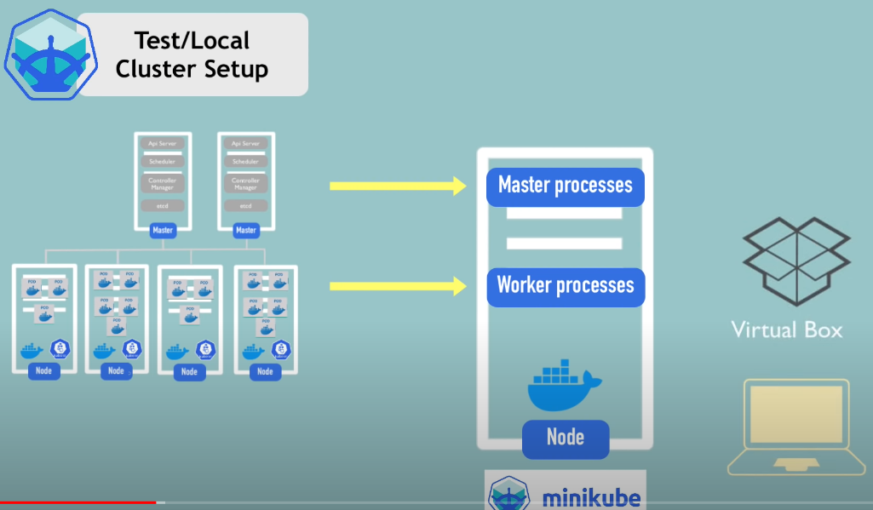

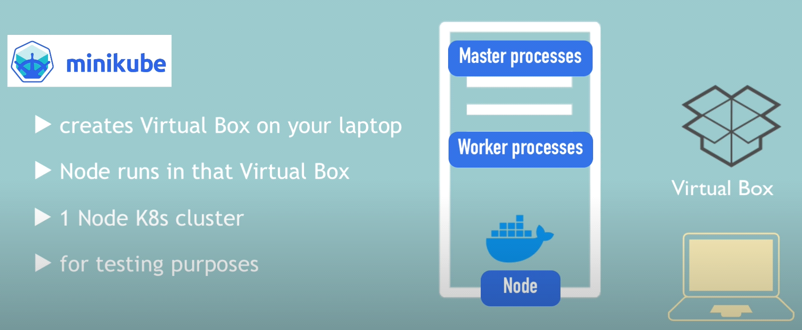

Kubectl:

Now that we have minicube i.e single node K8s cluster we need to create PODs and components which can be done using kubectl

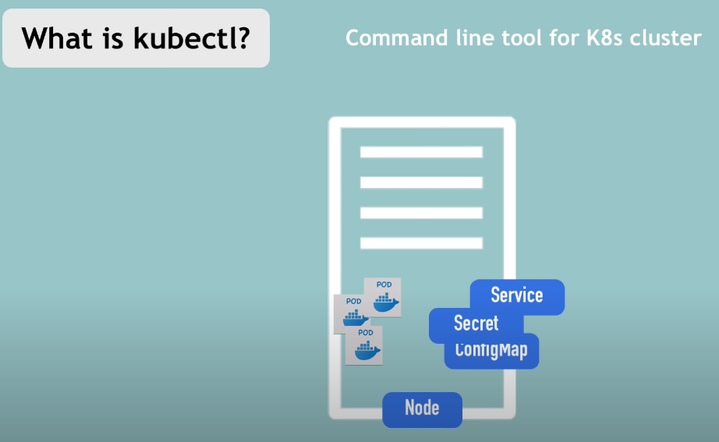

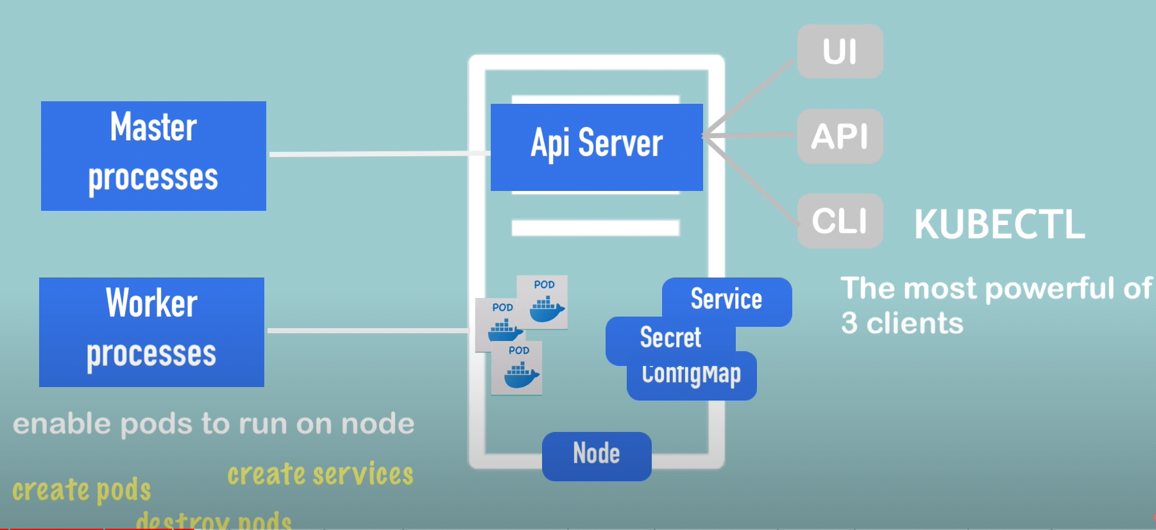

Note: kubectl is the command line tool for any type of kubernetes cluster (cloud cluster) and not just minikube cluster

Install minikube:

Pre-install step: you need virtualization to install and run minikube

Install hypervisor if you don’t have any like for example: “Virtual Box”

Note: minikube has “kubectl” as dependency which gets installed implicitly while installing minikube.

For WINDOWS:

<https://minikube.sigs.k8s.io/docs/start/>

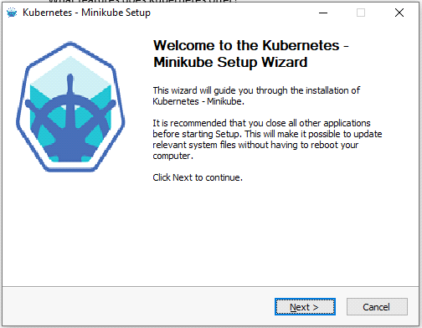

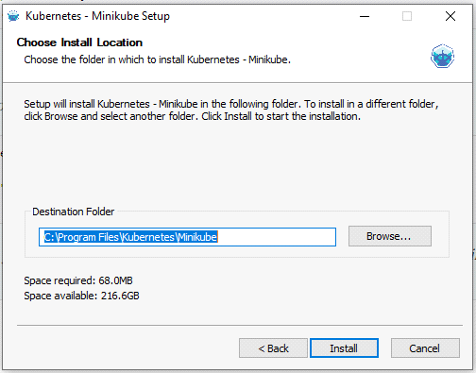

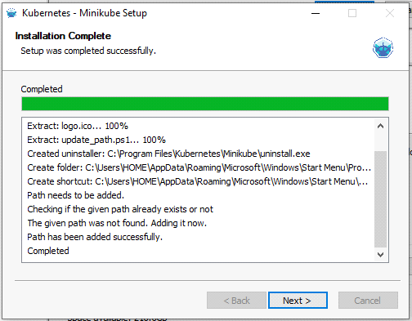

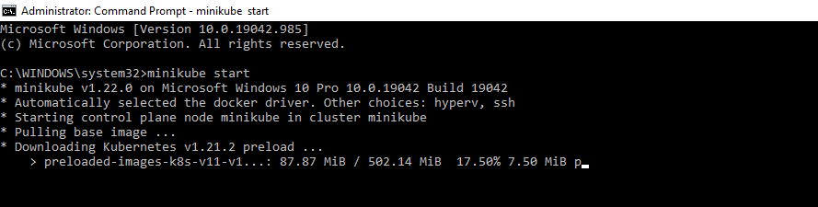

All commands: <https://gitlab.com/nanuchi/youtube-tutorial-series/-/blob/master/basic-kubectl-commands/cli-commands.md>

minikube start (Windows)

For MAC OS:

brew update

brew install hyperkit [not needed if hyperversion already enabled]

brew install minikube

Note: For those who do not have brew try the below command:

/bin/bash -c "$(curl -fsSL <https://raw.githubusercontent.com/Homebrew/install/master/install.sh>)"

To install the latest minikube stable release on x86-64 macOS using binary download:

curl -LO https://storage.googleapis.com/minikube/releases/latest/minikube-darwin-amd64

sudo install minikube-darwin-amd64 /usr/local/bin/minikube

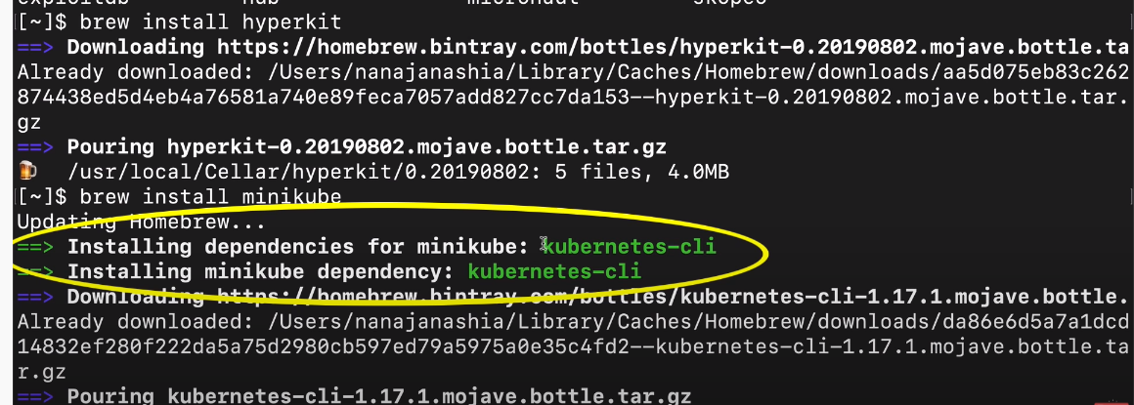

Post installation Try this command: kubectl

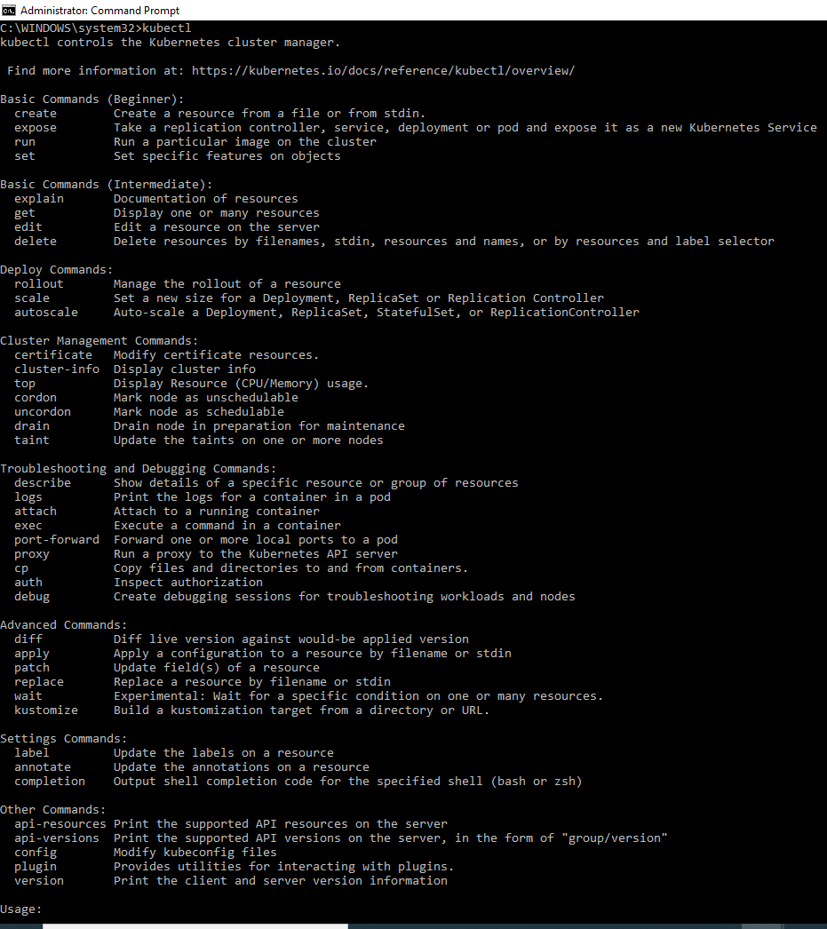

minikube

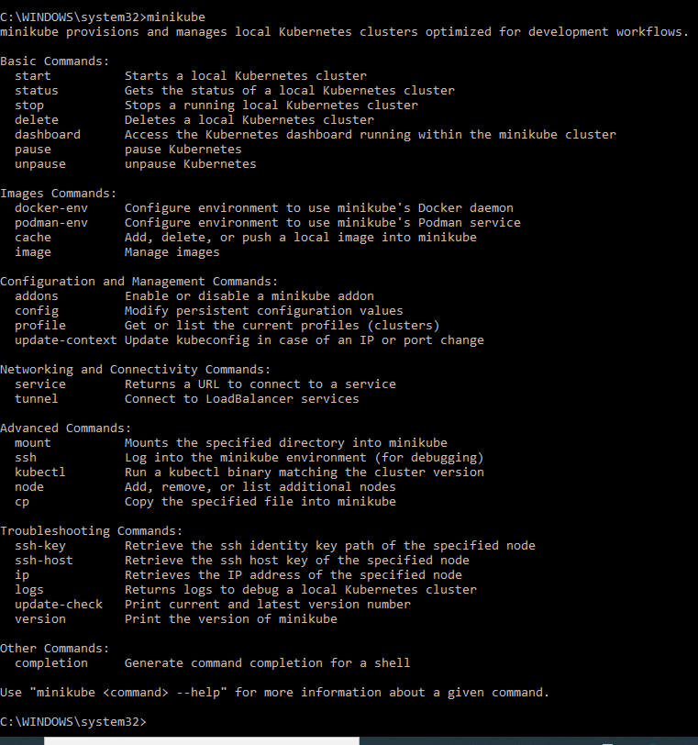

To Start a basic minikube cluster: minikube start [ you can explicitly also specify which hypervisor minikube should use i.e –vm-driver=hyperkit ]

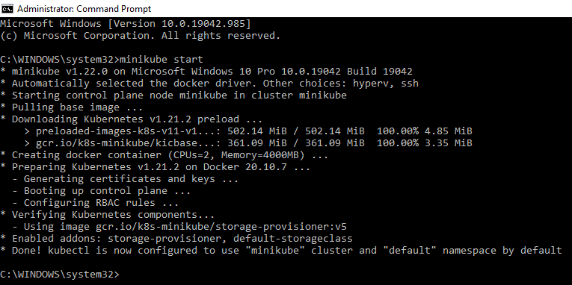

kubectl get nodes

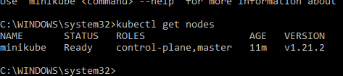

minikube status

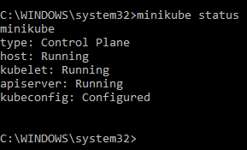

kubectl version



Note:

Minikube is meant “ONLY” to startup and delete the cluster.

For all other stuff (configurations) we use kubectl.

kubectl get nodes

kubectl get pod

kubectl get services

As evident from the output there is no POD created.

To see what all that can be created try the command kubectl create -h

Are you Surprised to see there is no command to create POD? Answer: Goto page 74 of this document regarding component named “Deployment”

kubectl get deployment

kubectl get replicaset

kubectl get all

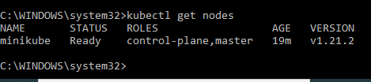

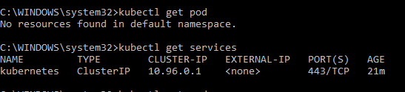

List all components kubectl can create:

kubectl create -h

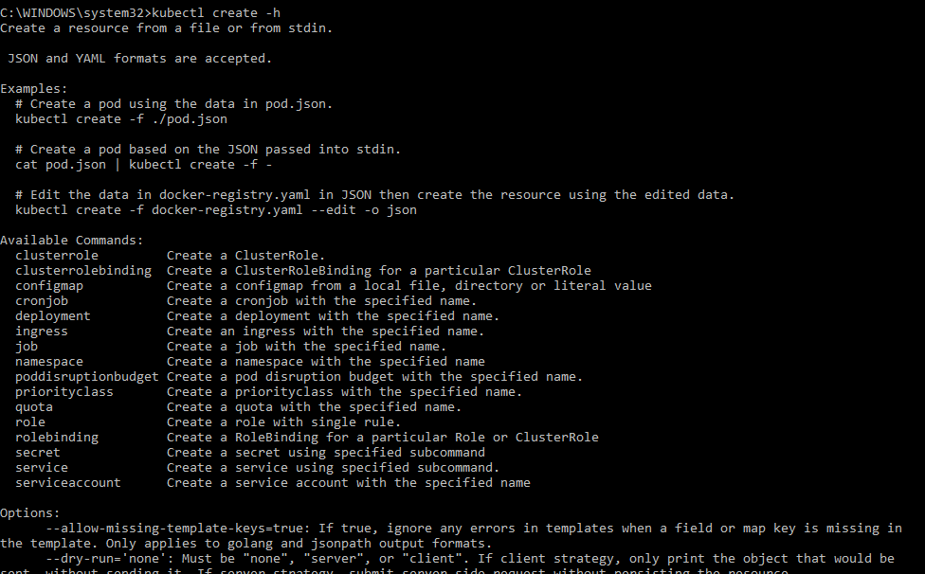

Create a POD (Note you need to provide a Docker Image for the POD’s container to create like todoapp or nginx) -> kubectl create deployment nginx-depl --image=nginx

(Does not like underscore in the name nginx_depl)

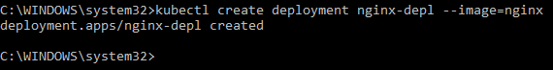

kubectl get deployment

kubectl get pod

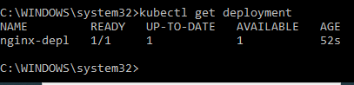

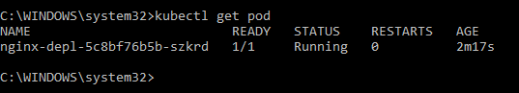

Between deployment and pod is another layer called replicaset.

kubectl get replicaset

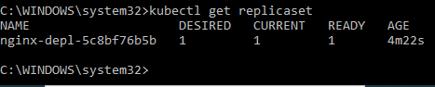

You will never be working on replicaset directly and leave it for the cluster to manage solely.

Conclusion: The POD name is <deployment_name>-<replicaset_name>-<pod_name>

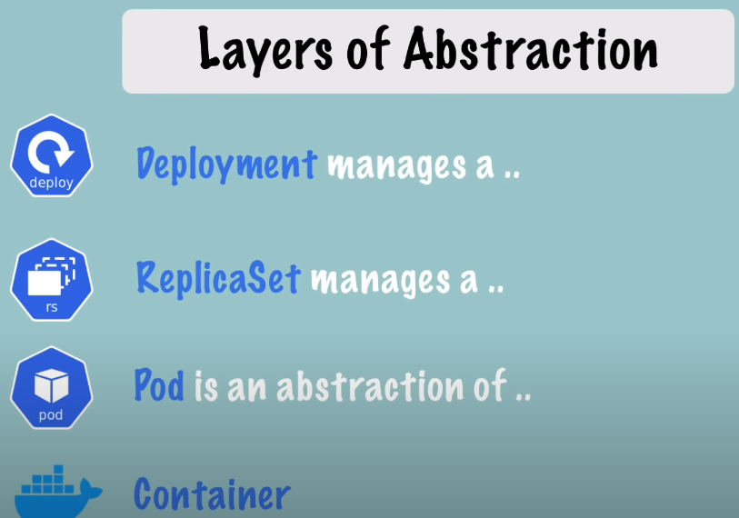

**Architecture of Deployment in kubernetes**

**Deployment manages -> replicaset -> POD (abstraction of) -> container**

If you wish to replicate multiple PODs then supply options to this command `kubectl create deployment` where you can specify multiple PODs (replicas).

To open deployment configuration file for editing use command-line:

kubectl edit deployment nginx-depl



Immediately after editing the image: nginx to -> nginx:1.16

Try, kubectl get pod; to see that the existing POD is terminating and the new pod with the 1.16 version is coming up.

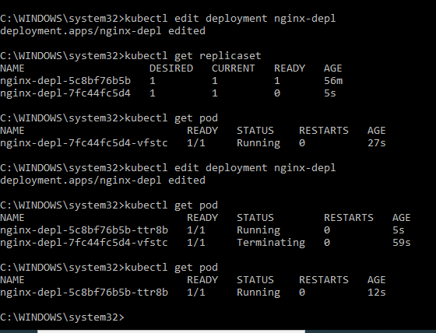

0/1 means that the (container is running) / inside the POD.

Kubectl get replicaset

Keeps current and current – 1 status of the PODs and not all the statuses.

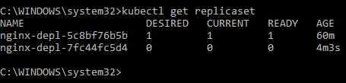

Conclusion: We edited the component called “Deployment” ONLY and everything below that got updated automatically like the “POD” and “Replicaset”

To view POD logs use this command:

kubectl logs <pod_name> i.e very similar to docker logs.

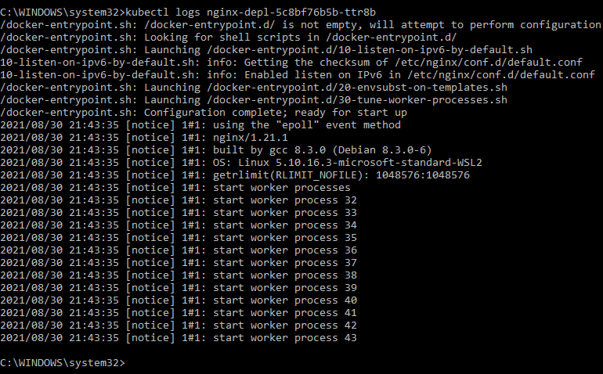

To get more detailed information about POD

kubectl describe pod nginx-depl-5c8bf76b5b-ttr8b

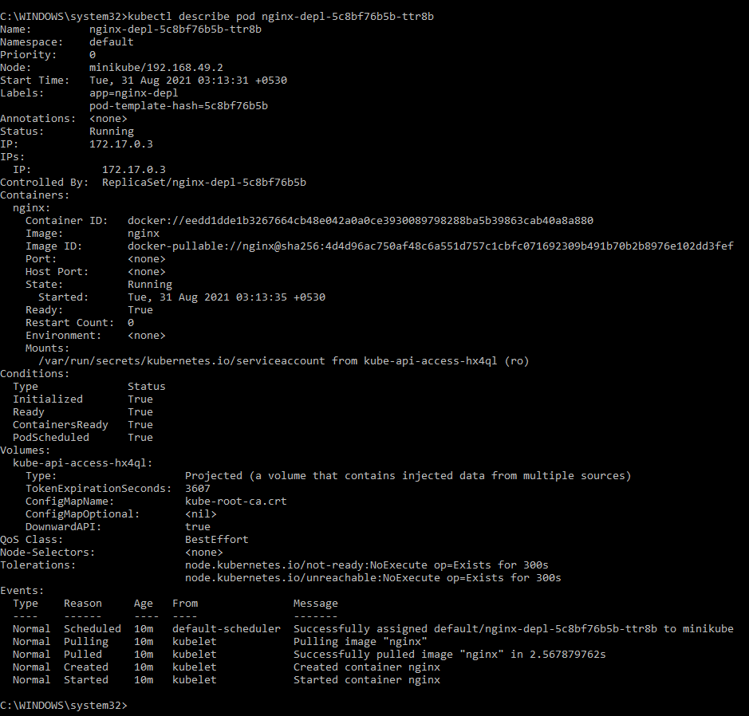

To login to an existing POD interactively use

kubectl exec -it nginx-depl-5c8bf76b5b-ttr8b -- bin/bash

To keep it light weight even ps utility is kept out of the container.

To install ps utility

apt-get update

apt-get install -y procps

ps -ef | grep nginx

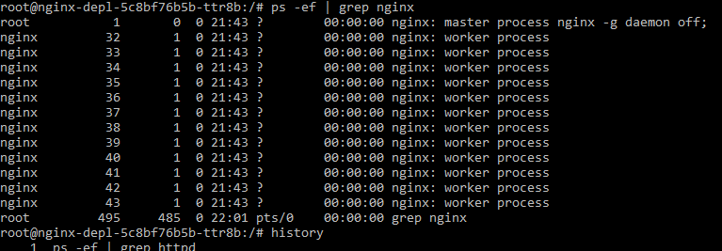

Deleting the deployment will delete the replicaset as well as the POD

Kubectl delete deployment nginx-depl

Another approach is to create a deployment using configuration file and not command-line like we already did.

cat C:\Users\HOME\nginx-deployment.yaml

apiVersion: apps/v1

kind: Deployment

metadata:

name: nginx-deployment

labels:

app: nginx

spec:

replicas: 1

selector:

matchLabels:

app: nginx

template:

metadata:

labels:

app: nginx

spec:

containers:

- name: nginx

image: nginx:1.16

env:

- name: JDK_HOME

value: "/tmp/"

ports:

- containerPort: 80

kubectl apply -f nginx-deployment.yaml

When the replica was 1 versus when replica was 3

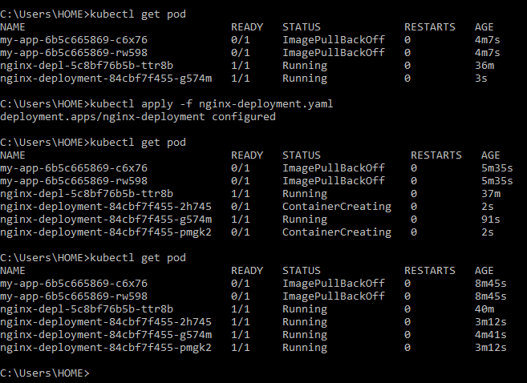

Each kubernetes configuration file has 3 parts

The first two lines are about what we are creating i.e deployment or service.

* Metadata
* Specification
* Status [Automatically generated and added by Kubernetes in “etcd” at runtime] Refer Page: 85 for “etcd” of this document.

A diff in the specs and status is what helps kubernetes understand that there is an issue with the setup.

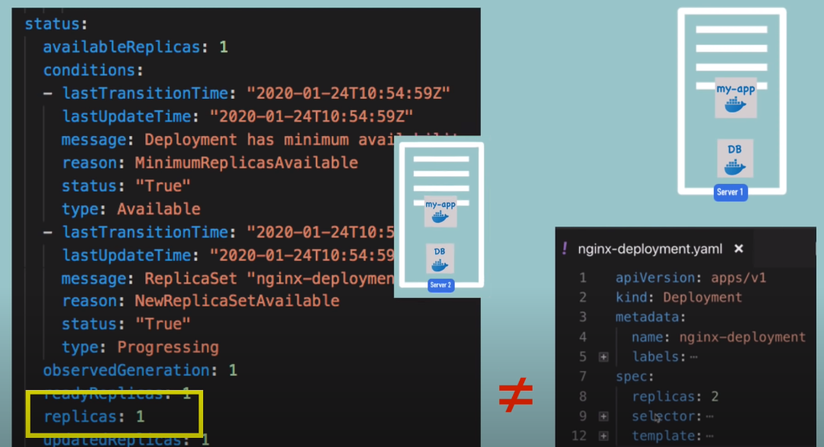

Discuss YAML file syntax

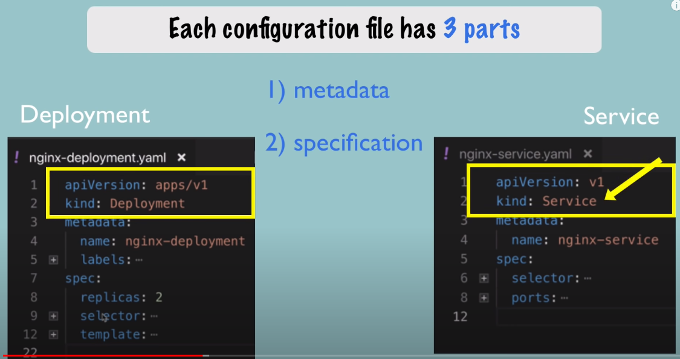

Verify your configuration using YAML online editor like: <https://codebeautify.org/yaml-validator>

The inner template specs have definition blueprint for POD

The metadata contains labels while the specs contain selectors

The selectors for POD matching labels is how the Deployment know which POD belongs to which Deployment component. Same way the Service selectors matches Deployment labels to know which POD it belongs to. See below:

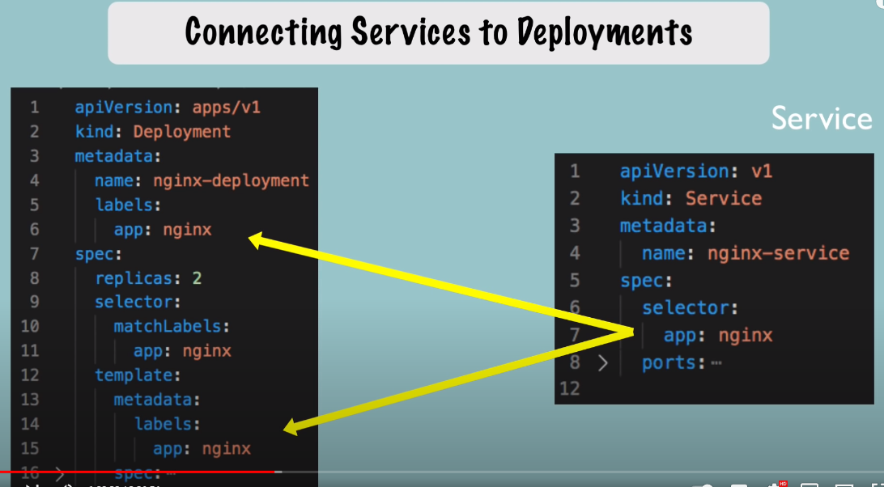

Nginx-service.yaml has port mapping for listen and target port matching the port of the POD.

Cat nginx-service.yaml

apiVersion: v1

kind: Service

metadata:

name: nginx-service

labels:

app: nginx

spec:

selector:

app: nginx

ports:

- protocol: TCP

port: 80

targetPort: 8080

How does a service port map to the PODs port ?

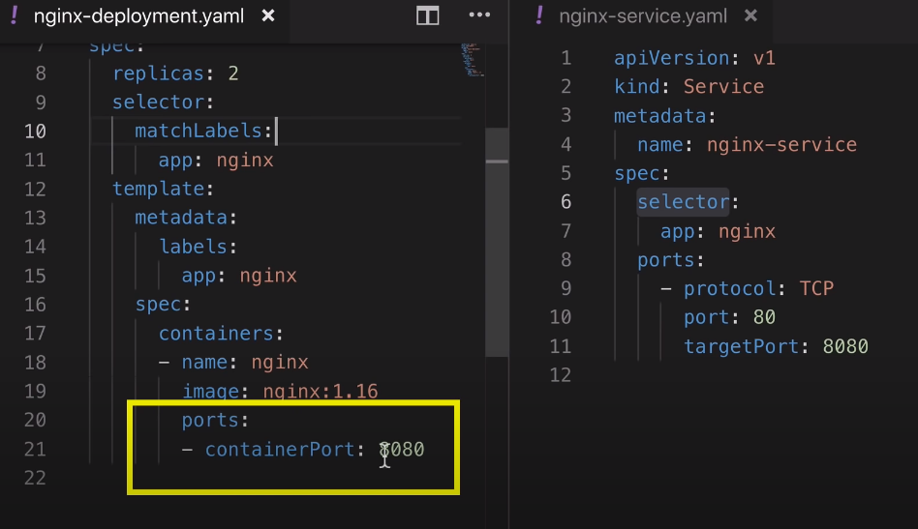

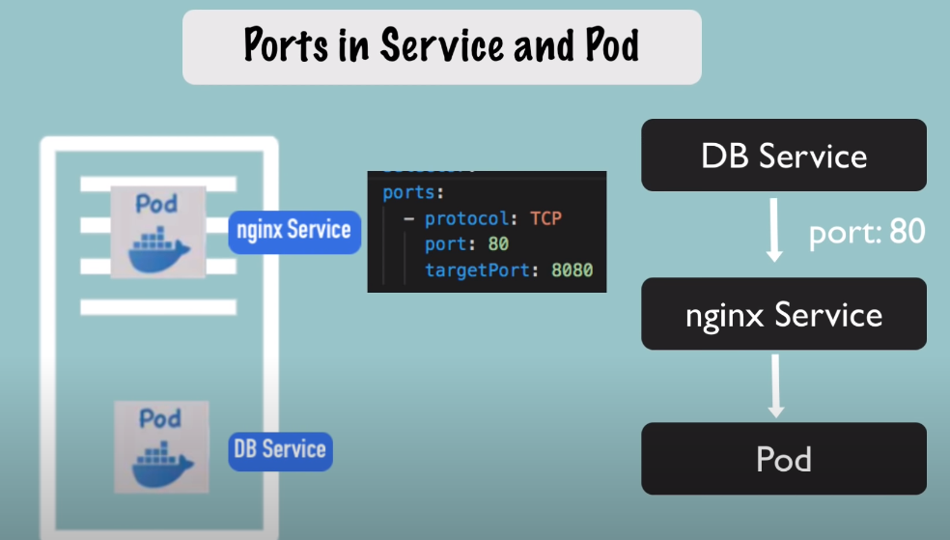

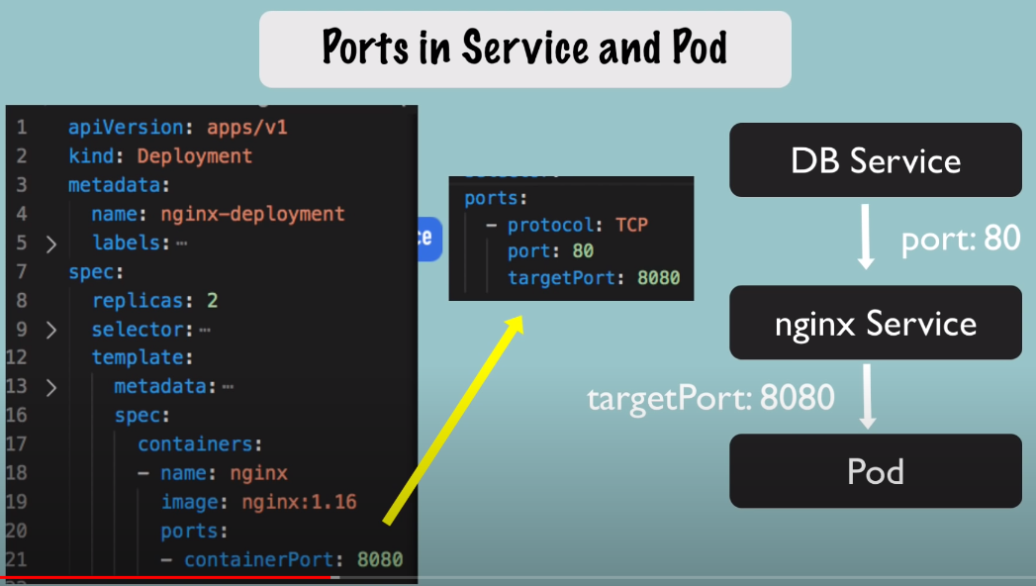

kubectl apply -f nginx-deployment.yaml

kubectl apply -f nginx-service.yaml

kubectl get service

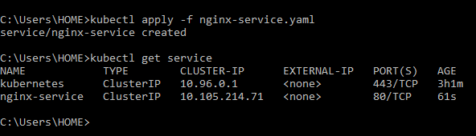

kubectl describe service nginx-service

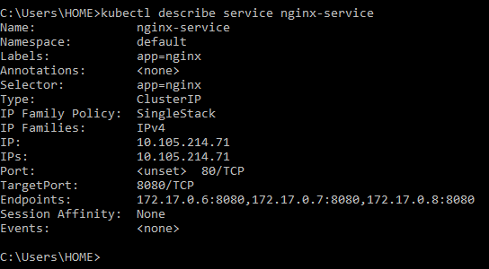

Note the Endpoints. Now, to get more detailed info of a POD use:

Kubectl get pod -o wide

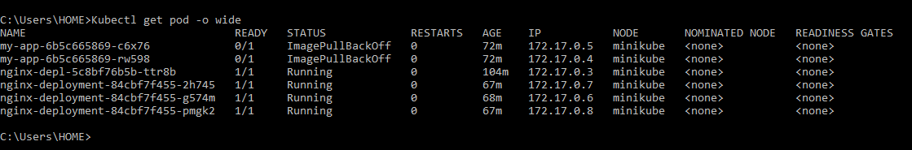

If the ips match we can conclude that the service has the right endpoints (matching the PODs)

To get updated configuration (which will include the status) of Deployment component use below command:

Kubectl get deployment nginx-deployment -o yaml > nginx-deploy-result.yaml

Compare the current status YAML with the one we configured.

Error when the node is down + Delete deployment

kubectl delete -f nginx-deployment.yaml

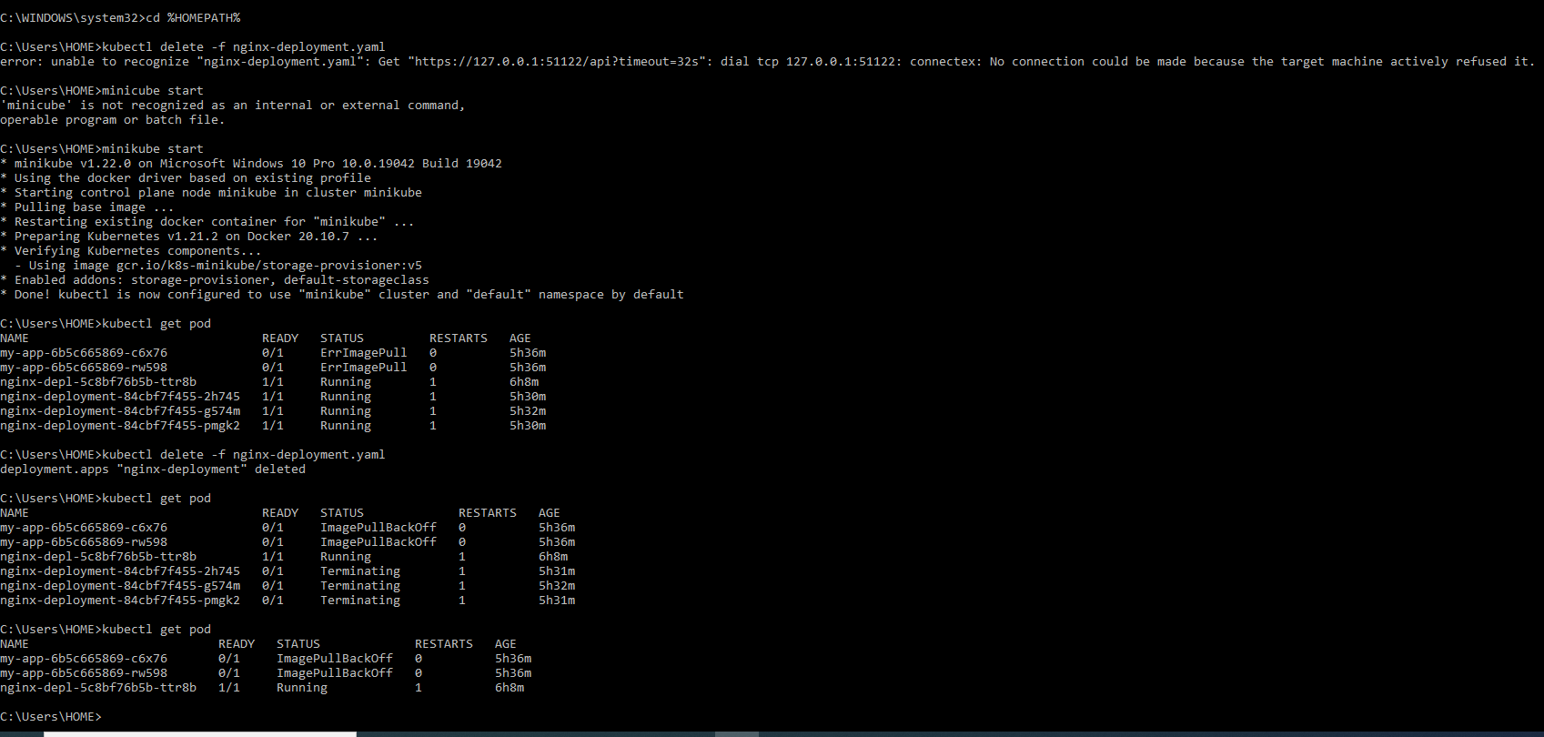

Deleting POD with status -> ErrImagePull

kubectl delete pods my-app-6b5c665869-c6x76

